# Abstract

200-300 words written last

# Executive summary

1 page

Table of Contents

1 Abstract 1

2 Executive summary 2

3 Table of Figures 5

4 Table of Tables 6

5 Table of Equations 7

6 Table of Snippets 8

7 Notes on Structure 1

8 Introduction and Outline 3

8.1 Aim of Thesis 3

8.2 Summary of Achievements 3

9 Background and Problem breakdown 4

9.1 Prior Art 4

9.2 Preprogramed Control 7

9.3 Force Based Control 7

9.4 Proximity as a solution 8

9.5 Functionality Requirements 10

10 Scope 11

10.1 Proof of Concept 11

10.2 Variations 13

11 Functional Decomposition 14

12 Subsystem One: Relative Position of Pilot 16

12.1 Definition and Requirement 16

12.2 Background and Prior Art 17

12.3 Approach and Execution 19

12.4 Results and Discussion 25

13 Subsystem Two: Force applied by and to Exoskeleton 26

13.1 Requirements and Functional Decomposition 26

13.2 Background and Prior Art 27

13.3 Approach and Execution 27

13.4 Results and Discussion 27

14 Subsystem Three: Controls and Decision Making 28

14.1 Requirements and Functional Decomposition 28

14.2 Background and Prior Art 28

14.3 Approach and Execution 28

14.4 Results and Discussion 28

15 Subsystem Four: Communications 29

15.1 Requirements and Functional Decomposition 29

15.2 Background and Prior Art 30

15.3 Approach and Execution 31

15.4 Results and Discussion 33

16 Subsystem Five: Actuation Systems 34

16.1 Requirements and Functional Decomposition 34

16.2 Background and Prior Art 34

16.3 Approach and Execution 35

16.4 Results and Discussion 38

17 Integrated Exoskeleton 40

17.1 Requirements and Functional Decomposition 40

17.2 Prior Art 40

17.3 Solution 40

17.4 Implementation 40

17.5 Results 40

18 Results and Performance 41

19 Recommendations and Further Works 42

19.1 SS1 42

19.2 SS2 42

19.3 SS3 42

19.4 SS4 42

19.5 SS5 42

19.6 Exoskeleton 42

20 Conclusion 43

21 Bibliography 44

22 Appendices 47

22.1 Representative Movements 47

22.2 Unsuitable Proximity Sensors 49

22.3 Code 51

22.4 PCBs 52

22.5 CAD drawings 53

# Table of Figures

Figure 1: Assisted-walking Device (Cybernetic Zoo, 2010) 4

Figure 2: G.E. Hardiman I Exoskeleton (Cybernetic Zoo, 2010) 5

Figure 3; System Decomposition 14

Figure 4: Point and Angle to Orientation 15

Figure 5: SS1 Breakdown 16

Figure 6: IR Proximity Sensing 18

Figure 7: TRCT5000 (Vishay Semiconductors, 2017) 20

Figure 8: TRCT5000 Topology 20

Figure 9: IR Sensor Mount Header Topology 21

Figure 10: IR Sensor Mount PCB Depiction 21

Figure 11: Fabricated IR Sensor Mount PCB 21

Figure 12: Hose Clamp (Bunnings, 2018) 22

Figure 13: Cable Tie (Computer Cable Store, 2018) 23

Figure 14: Mount Structure 23

Figure 15: Mount Structure (Single) CAD 23

Figure 16: Printed Mount Structure (Single) 23

Figure 17: Sensor Frame 24

Figure 18: Constructed Sensor Frame 24

Figure 19: Subsystem One (Assembled) 25

Figure 20: SS2 Breakdown 26

Figure 21: SS4 Breakdown 29

Figure 22: Packet Protocol 32

Figure 23: SS5 Breakdown 34

Figure 24: MG995 - High Speed Metal Gear Dual Ball Bearing Servo 35

Figure 25: 900-00008 - Continuous Rotation Servo 36

Figure 26: Test A Configuration 36

Figure 27: Test B Configuration 37

# Table of Tables

Table 1: Functional levels and associated movements 10

Table 2: UART Pins 29

Table 3: UART Configuration 29

Table 4: DMA Configuration 29

Table 5: Packet Protocol 30

Table 6: PWM Configuration 35

Table 7: Motor PWM Requirements 36

# Table of Equations

**No table of figures entries found.**

# Table of Snippets

# Notes on Structure

The traditional thesis structure is broadly defined as:

* Introduction;
  + Background;
  + Scope; and,
  + Outline.
* Theory;
* Methods;
* Analysis;
* Discussion; and,
* Conclusions.

Due to the nature of the works competed in this thesis liberties were be taken to improve flow, clarity, and communication in general.

As per conventional structures, the project is introduced, and some background information relating to the context of the project is presented. From this the scope and focus of the thesis is derived and defined. Here deviation begins, rather addressing the project as a whole, which would require retention of swaths of unrelate information as one progresses through theory and methods, instead the project is broken down functionally into the major subsystems required for a successful project (as defined in the scope).

Within each of these subsections standard structure is employed. The purpose and context of the subsystem is explained, and the requirements for practical completion are detailed. From here a literature review is conducted as appropriate for each subsystem, explaining technologies or theory as needed. From this the specific methods, in design and implementation are detailed for each subsystem, e.g. the engineered design, and then the specific technology employed to implement the design. Finally, analysis is conducted on the outcomes of the subsystem in the context of the functional requirements defined.

The intention of this method is to allow for a consistent singular train of thought, where information on a system is presented sequentially (i.e. a single train of thought), rather than all information relevant to the thesis presented in order of type.

Once the subsystems are discussed, the same process (scope, requirements, theory, method, and analysis) is applied to the task of integrated all the major subsystems into a single supersystem. This section details the complete system and the performance of the exoskeleton developed. This section presumes knowledge of the subsystems but does not demand knowledge of their intricacies. The intention is that compartmentalising the details of the subsystems it is possible to discuss the design of the exoskeleton in general with brevity and clarity.

Finally, the results of the project are discussed, before the implications, recommendations, and conclusions of the project are discussed.

Readers primarily concerned with the outcomes of the proof of concept and thesis and not the specifics of how it was done, may find that reading **Error! Reference source not found.** and then skipping to **Error! Reference source not found.** (referencing the earlier sections of the documents as needed) as the most palatable method of consuming the document. Through this they may understand the projects context, what was done, and the results, without the dry technical details.

# Introduction and Outline

A powered exoskeleton, or exoskeleton, is wearable technology the amplifies and augments the pilot’s physicality. Through direct mechanical assistance via actuators, the pilot’s effective strength may be increased. By supplementing the strength required to complete a task the energy requirements of the task may be reduced; effectively increasing the pilot’s endurance. Possible applications for exoskeletons include: military operations, emergency & rescue, physical/manual labour, and medical applications.

Two major factors impact the viability of exoskeleton technology: power supply, and control. This thesis shall address one facet of the difficulties or exoskeleton control. Current exoskeleton control methods are inadequate due to mechanical constraints and the limitations of the control methods. Imperfections in mechanical design may result in a limited range of movement affecting the suits utility (e.g. A rigid spine in a confined space). Current methods of control use either force-based sensors or preprogramed movements. Finite sets of preprogramed movements are insufficient for dynamic environments and are only suitable for applications where the pilot is incapable of properly piloting the system (Charara, 2015). Force based methods encounter stability problems and may increase the exertion required to complete a task (Keller, 2016).

Instead this thesis will focus on the development of a novel power exoskeleton control method based on detecting the pilot’s position relative to the suit to maintain a constant offset; specifically focusing on the development of the controls and perception systems required to direct an exoskeleton.

An offset-based control system, by maintaining a constant offset from the user, may exist as a concentric outline (or *bubble*) of the user, mirroring their actions. Thus, to control the system the pilot simply needs to assume the desired position of the suit, and the suit shall mimic them. By mimicking the user’s actions, the suit is more intuitive that force based and preprogramed methods. The resulting system requires no physical contract with the pilot to control. With no physical contact required to operate the system the energy required from a pilot to complete a task with a load is effectively the same as completing the task with no load. Therefore, with any arbitrary load the user has the endurance to perform the task as if there no load at all.

Kt

## Aim of Thesis

## Summary of Achievements

# Background and Problem breakdown

## Prior Art

Exoskeleton technology began in 1890 (United States of America Patent No. 440684, 1890), with Nicholas Yagin, with the development of a passive device that used compressed gas to assist in human movement, see Figure 1: Assisted-walking Device (Cybernetic Zoo, 2010).

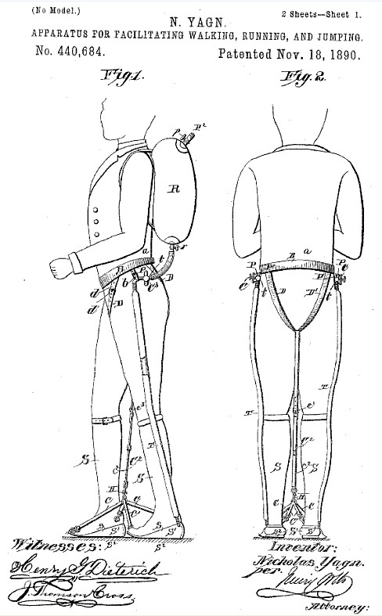

Figure 1: Assisted-walking Device (Cybernetic Zoo, 2010)

However, it was not until the 1960s that the first attempt at a practical power exoskeleton was developed. The Hardiman (Keller, 2016) shown in Figure 2: G.E. Hardiman I Exoskeleton (Cybernetic Zoo, 2010), created by General Electric, was ground-breaking but non-viable due to its extreme weight (double its maximum load) and control problems. The suit, when used as a complete system instead of in parts, was subject to dangerous violent uncontrolled movements and the master-slave control system suffered debilitating lag.

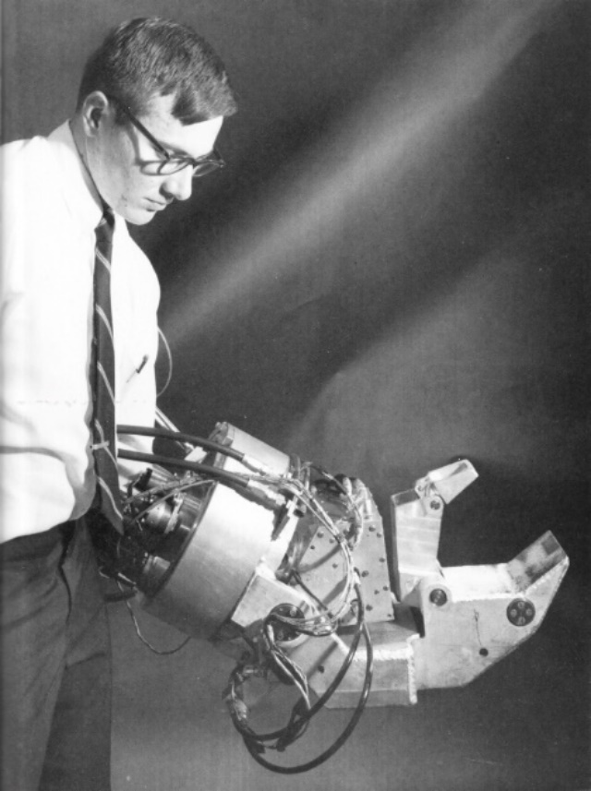

Figure 2: G.E. Hardiman I Exoskeleton (Cybernetic Zoo, 2010)

Prospective uses for exoskeletons usually involve a scenario where a human user may require the strength and endurance of a machine, but circumstances result in wheeled vehicles are undesirable. Examples of possible applications include:

* Military Operations: operators are required to carry head loads over longs distances, lift large weights, and operate in dynamic and unruly conditions. Difficult terrain, heterodox environments, and general disarray result in heavy machinery often being unsuitable for certain circumstances. From urban to jungle operation exoskeletons provide possible utility.
* Rescue and evacuation missions: Rescue operations feature similar constraints to military operation with the additional concern of environmental hazards and structural collapse. In the event of a fire or chemical incident, the safety equipment and tools can be large, heavy, and cumbersome; exoskeletons can alleviate some of this burden. Where structures are damaged or collapsed an exoskeleton can provide the extra strength required to save a life,
* Medical Systems: When amputation, age, or illness results in an individual suffering from reduced mobility and strength exoskeletons present exciting opportunities to compensate for their pilot’s impediments.
* Construction & Physical Labour:

These applications represent some of the broader more immediately uses for exoskeletons, neglecting the role of specifically designed exoskeletons for niche tasks: shock absorbing legs for parachutes/paratroopers, self-propelled underwater diving suits, etc.

Since the Hardiman, exoskeletons have been plagued by the same two major problems that have prevented their use in real world applications: power to weight ratio/power supply and control. The following outlines current developments in exoskeleton technologies.

### HULC

The Human Universal Load Carrier (HULC) is battery-powered lower extremity exoskeleton initially developed by Berkeley Robotics and Human Engineering Laboratory, before entering an exclusive licensing agreement with Lockheed Martin in 2009 (Axe, 2012). The system uses hydraulics to amplify the pilot’s knees and hips while supporting a load of 90kg. Designed for military applications it claims six hours of battery and uses force-based sensors for control.

The HULC was abandoned as” it proved impractical, exhausting users instead of supercharging them” (Cornwall, 2015) and has been succeeded by the TALOS project (Cornwall, 2015).

### EskoGT

In 2010 the original developer of the HULC, Esko Bionics revealed the Exoskeleton Lower Extremity Gait System (eLEGS) (Charara, 2015). With a maximum battery life of 6 hours and maximum gait of 3.2m/s (Charara, 2015), the system uses pushbuttons and force-motion sensors for control. Specially design for medical applications, the exoskeleton uses preprogramed movements to aid the mobility of stroke and spinal injury patients.

The suit is ill suited for dynamic environments, with its finite range of movements prohibiting stairs and uneven surfaces. While the suit may assist those with “upper extremity motor function of at least 4/5 in at least one arm” (Charara, 2015), the suit is slower than a wheelchair and is not an improvement on standard human movement.

### Raytheon XOS Exoskeleton

The 2008 Raytheon XOS Exoskeleton developed by Raytheon is a full body exoskeleton that can support up to 23kg on each arm (Karlin, 2011). The suit uses force-based sensors for control. Despite claims that the exoskeleton would be ready for production by 2016, they have made no public comments on progress since 2011 (Karlin, 2011).

### Warrior Web

The Warrior Web non-rigid exoskeleton was first demonstrated at the 2016 DARPA Demo Day (Cornwall, 2015). Developed by DARPA, it used preprogramed commands to assist with the user’s ankle motions. However, it was unpredictable in uneven terrain, malfunctioned, and could not transition readily between a walking and running state (Cornwall, 2015).

### Hybrid Assistive Limb (HAL)

In 1997 Cyberdyne unveiled the Hybrid Assistive Limb (HAL) (Cyberdyne, 2016). The HAL’s iterations include a battery-powered lower extremity exoskeleton and a full body exoskeleton (Cyberdyne, 2016). Through a combination of bioelectrical sensors and force sensors the HAL measured muscle contracts to trigger preprogramed movements.

The system has had mixed success, and despite applying for USA FDA approval in 2014, the HAL is yet to be permitted for use in the US (Cyberdyne, 2015).

## Preprogramed Control

Preprogramed control methods consist of a set of specific movements that are triggered in one way or another. HAL measures contractions in the arms of patients to trigger as the swing them back and forth to trigger left-foot right-foot walking motions. Warrior Web applies torque to the ankle of the user (assisting them walk) when movement is detected.

These systems are inherently limited in their utility. By having a finite or procedurally generated set of movements there will always be scenarios or circumstances where the set of movements is not applicable. In real dynamic environments (e.g. military, rescue & evacuation, and physical labour) dynamic controls are required.

As noted by Dunietz when using an exoskeleton with preprogramed controls, the ”human does try to join in the motion, the two get in each other’s way, cancelling out the gains for all but the most extreme disabilities.” (Dunietz, 2017) Though this we seem the limited applicability of preprogramed movements; in circumstances where the movement of the pilot is so limited and restricted (e.g. via disability) that any system is an improvement. For an able-bodied pilot preprogramed movements are ”a bit like being a marionette with four wires controlling my legs” (Cornwall, 2015) and inadequate.

## Force Based Control

Force based control systems use force applied to the internals of a suit to determine the users desired position. The force applied indicates the direction and magnitude of movement. Force based systems are often inadequate for practical applications due to the sensitivity of force input. Systems which are too sensitive may develop jitter, and lags between sensing and movement combines with physical inertia may result in the system applying force to the user, creating an unstable feedback loop. Systems with are insensitive are slugging and require the pilot to push and move against the suit. Using these systems can be sluggish, cumbersome, and exhausting to use.

As the only mechanism for detecting position for a force-based system is the user making contact with the suit misalignments in sizing can result physical dead bands when users are unable to touch the suit and the control system is effectively blind. Additionally, suits which maintain constant contact with asymmetrical body parts may interpret asymmetry as force input and therefore require constant active resistance from the user to control.

Finally, force-based systems do not distinguish between the force output of the system and the speed desired. If a user wishes to move quickly they must apply a large amount force to the system, if the suit encounters and obstacle this movement is then interpreted as a large amount of force applied to the object. There is no mechanism for quick safe movements.

For exoskeletons in dynamic real-world environments to be viable, responsive, and safe improvement on the existing force-based sensing methods are required.

## Proximity as a solution

Consider the following:

1. For controlling the suit, it may be assumed that the user is inside the suit during operation;
2. The users desired position for the suit may be treated as their personally bodily position;
3. Thus, the positional error between the desired configuration of the suit and the actual configuration of the suit is the difference between the configuration of the pilot and the configuration of the exoskeleton;
4. If the position of the pilot relative to the suit is measured and known, then the position of the suit relative to the pilot can be known; and,
5. Therefore, the suit can be controlled accurately (that is to say, error can be known at any time) by observing the position of the pilot relative to the suit; with no abstraction between measurement type (given in position) and desired state (given by position).

It is proposed to develop a proof of concept for an exoskeleton control system based on measurement of the pilot’s position/proximity the suit. By maintaining a constant offset from the user, the exoskeleton may exist as a concentric outline (or *bubble*) of the user, mirroring their actions.

Consider the following:

1. In a circumstance where the exoskeleton encounters an obstacle it is desirable to regulate and control the force output of the system;
2. It is desirable to decouple the control of force output and speed (a noted flaw with force-based control methods);
3. If the force output of the system is monitored by sensing its interactions with the environment, then the force output of the system can by regulated by then regulating the actions of it actuators; and,
4. Therefore, to ensure safe movement that does not apply undue for to the environment the force output of the system should be measured and regulated at external contact points.

It is proposed that for a position-based exoskeleton control system that the force output is directly measured (at contact points) to ensure safe and controlled operation.

Consider the following:

1. If the system applies force up to a safe maximum, then once that maximum is met then the exoskeleton will stop applying force to match pace with the user’s movement;
2. Under these circumstances the constant offset between the user and the system will not be maintained;
3. The user then may make contact with the internals of the suit;
4. It is possible to use the pilot continuing attempt to move in the direction of the opposing force as intent to increase force output of the suit;
5. By measuring the force applied by the user to the inside of the suit at contact points it may be possible for the user to indicate the desire for increased force output;
6. By measuring the force applied to external and internal contact points by the suit and the pilot respectively it is possible for the suit to operate with safe low force outputs which a pilot may override when increase force output is desired; and,
7. By using this system when the actuators are capable of strength beyond normal human capabilities, the pilot can effectively command and control superhuman strength in a safe and intuitive manner.

It is proposed to properly control the force output of the system the forces applied internally and externally to the exoskeleton are measured, and the force applied by the user to the internals of the suit are used to control the force output of the systems actuators.

The subsequent system in summary:

* Uses position sensors to determine the desired configuration of the exoskeleton from the bodily configuration of the pilot;
* Uses external sensors to regulate the force output of the system, maintaining a safe maximum; and,
* Measures force applied internally to determine the force output of the system.

The potential benefits of such a system are summarised as follows.

### Dynamic control

By mirror the movements of the user, with a sufficient mechanical design, the movements possible by the system is only limited by the capabilities of the pilot. Therefore, in any system which a human could navigate the system should be able to operate. Compared to preprogramed systems, it will be possible to navigate uneven terrain, switch contexts, and perform in unpredictable environments.

### Intuitive control

The system described shall provide more intuitive control relative to other solutions. If the pilot seeks to move the left leg of the system, they must simply move their left leg. If the suit makes contact with an object the suit will cease movement. If the pilot wishes to push the object, they simply need to push the object through the suit. The pilot may control the suit as they would their own body.

### Effortless operation

The system significantly increases the effective endurance of the pilot while requiring no exertion to use. Using the example of carrying a heavy load, the user to walk normally requires a set amount of effort. With no load applied to the described exoskeleton the action should require the same amount of effort. With a sufficiently strong system, the system may be loaded with any arbitrary loaded but the increased effort to walk for the user will remain zero. The suit effectively gives the operator carrying a load the endurance of an operator with no load. Note, the magnitude of this benefit increases as the load increases.

## Functionality Requirements

To determine the viability of position-based exoskeleton control and develop a proof of concept it is essential to define the required capabilities of such a system. The following outlines the requirements for a functional exoskeleton system:

1. The system must be capable of steady-state/static operation;
2. The system must be capable of dynamic and actuated operation;
3. The system must be capable of dynamic and actuated operation with non-regulated/imprecise action;
4. The system must be capable of dynamic and actuated operation with regulated action; and,
5. The system must be capable of dynamic and actuated operation with regulated action under real-time conditions.

Should the system be capable of achieving level 5 operation it can be said to be fully functional. To assess the system’s level of functionality specific test case are required which may be considered representative movements of the requirements of each level of functionality. These are outlined as follows in Table 1: Functional levels and associated movements, these movements are detailed further in 22.1.

Table 1: Functional levels and associated movements

|  |  |  |  |  |  |
| --- | --- | --- | --- | --- | --- |
| Functionality Level | Representative Movement | Position of Pilot | Position of Exoskeleton | Force Applied by Pilot | Force Applied by Exoskeleton |
| L1 | Standing | **🗸** | **🗸** |  |  |
| L2 | Squatting | **🗸** | **🗸** |  |  |
| L3 | Stairs | **🗸** | **🗸** |  |  |
| L4 | Sitting | **🗸** | **🗸** | **🗸** | **🗸** |
| L5 | Sprinting | **🗸** | **🗸** | **🗸** | **🗸** |

As seen in Table 1: Functional levels and associated movements, there are four main pieces of information required to control the system at all levels. From the required information it is possible to create a system that can demonstrate all levels of functionality. Note that every representative movement for the system can be completed using only the lower extremities. This implies that to develop a proof of concept for position-based control only a lower extremity exoskeleton would be required.

# Scope

## Proof of Concept

The purpose of this thesis is to develop some of the major subsystems for a proof concept for a position-based exoskeleton control system. As noted above in 9.5, to create a proof of concept for the system only a lower extremity exoskeleton is required.

### Task Division

Creating said proof of concept however, is beyond the scale and scope of a single undergraduate thesis. Instead, the task was to be divided amongst two students, who would complete subsystems independently before integrating their work. It was eventually determined that the most elegant and functional demarcation of tasks would be to divide the system according to determining the required actions and performing the required actions. As such one student would be responsible for determining the required action from the exoskeleton systems to perform as desired, and one student would create a system that was capable of performing said actions. Broadly speaking, one student would design and create the sensing/perceiving and control systems for the proof of concept, and the other would create the structural and actuation systems of the proof of concept. The point of integration between the two systems would be a communication system capable of transmitting the desired action from one side to the other.

This student, Samuel Williams, was assigned the perception and control systems.

As a matter of clarification, it is important to note that the terms: actuation system, control system, perception system, and structural system are descriptive terms for the approximate scope and manner of certain groups of subsystems. They are not prescriptive and should not be treated as such, e.g. the mechanical structure required to hold the force sensors in place is structural but is within the scope of the perception systems not the structural system.

### Required Systems

A full functional decomposition can be found in 11.

Based on the specific division of tasks and the demarcation devised the following major functional requirements where identified.

1. Detection of Pilots position relative to the exoskeleton (detection of the suit’s absolute position would be the responsibility of the actuation system)
2. Force application of the exoskeleton to the environment and the pilot to the exoskeleton
3. Control system for determining required action (torque) from actuation system for correct operation
4. Communication from control & perception software to actuation system

### Inclusions (In Scope)

The commissioning of the following was considered within the of scope and the project:

* A lower extremity exoskeleton;
  + This includes feet, shins, thighs, and waist.
* Systems required to perceive the position of an exoskeleton pilot relative to the exoskeleton;
  + This includes the hardware, firmware, software, and mechanical structure required.
  + This is limited to detection of the position of the femur, tibia, and foot (treated as a singular entity). This does not include the detection of the position of individual toes or the internal actuation of the foot.
* Systems required to perceive the force applied by an exoskeleton pilot to an exoskeleton;
  + This includes the hardware, firmware, software, and mechanical structure required.
  + This is limited to the detection of force application at the soles of the feet and the rear of the pilot, zones required for the representative movements.
  + This is limited to a rigid sole without actuation, i.e. the foot may move and bend at the ankle but shall not be treated as flexing at the ball of the foot.
* Systems required to perceive the force applied by exoskeleton its environment;
  + This includes the hardware, firmware, software, and mechanical structure required.
  + This is limited to the detection of force application at the soles of the feet and the rear of the pilot, zones required for the representative movements.
  + This is limited to a rigid sole without actuation, i.e. the foot may move and bend at the ankle but shall not be treated as flexing at the ball of the foot.
* Controls theory required to determine the desired position of the exoskeleton; and,
  + This is limited to determining the desired torque and angle of the actuation systems.
  + This does not include determining power, voltage, or current requirements for actuators.
  + This does not include determining control inputs (e.g. pulse width modulation duty cycles) for the actuation systems.
* Communication systems required to relay system readings and desired actions between actuation system and controls system.
  + This is limited to creating an input and output connection for interfacing with the actuation & structural system via a common protocol.
  + This does not include the implementation of a communication protocol for the student responsible for the actuation & structural systems.

### Exclusions (Out of Scope)

The following tasks were considered out of scope and where excluded from the project:

* Commissioning of the torso, head, or upper extremities of an exoskeleton;
* Commissioning of actuation and structural systems required to support and actuate a lower extremity exoskeleton;
* Measurement of actuator positions or absolute exoskeleton position;
* Measurement of velocity, acceleration, or torque of any section of the exoskeleton;
* The development of an exoskeleton capable of supporting additional loads, i.e. carrying weights beyond those required for demonstration of proof of concept;
* There was no compensation for the flexion and distortion of body parts, e.g feet;
* Addressing power consumption problems, power-to-weight ratio problems, or price problems associated with exoskeletons;
* Actuation points (hip, knee, ankle) where constrained to 1 degree of freedom (DOF); and,
* Anything not in scope.

## Variations

The original proposed scope did not include the creation or design of any actuations, or the interfacing between the control and perceptions systems and the systems actuators. As the project progressed it became apparent that the mechanical/actuation section of the project would not be completed in time for proper operation and that to properly develop and demonstrate the functionality of the controls and perception system a testing rig would be required. As such, the original scope of the project was extended to include the design and create of a simplified actuation system capable of refining, testing, tuning, and demonstrating the controls and actuation systems.

Consequentially, a fifth major function requirement was added to the system:

1. Development of actuation system sufficient to demonstrate attainment of other major function requirements.

### Inclusions (In Scope)

The following was considered within the of scope and the project:

* Commissioning of actuators and mechanical structure required to demonstrate functionality of position detection systems;
* Commissioning of actuators and mechanical structure required to demonstrate functionality of force detection systems;
* Development of motor interface and power systems required to control actuators in the desired fashion.

No new exclusions were added to the project.

# Functional Decomposition

The system defined by the scope, see 10, was decomposed into its major function requirements as seen in 10.1.2. Functional decompositions were then completed for the major subsystems in their respective sections (see 12, 13, 14, 15, and 16). This section outlines that major function requirements of the system.

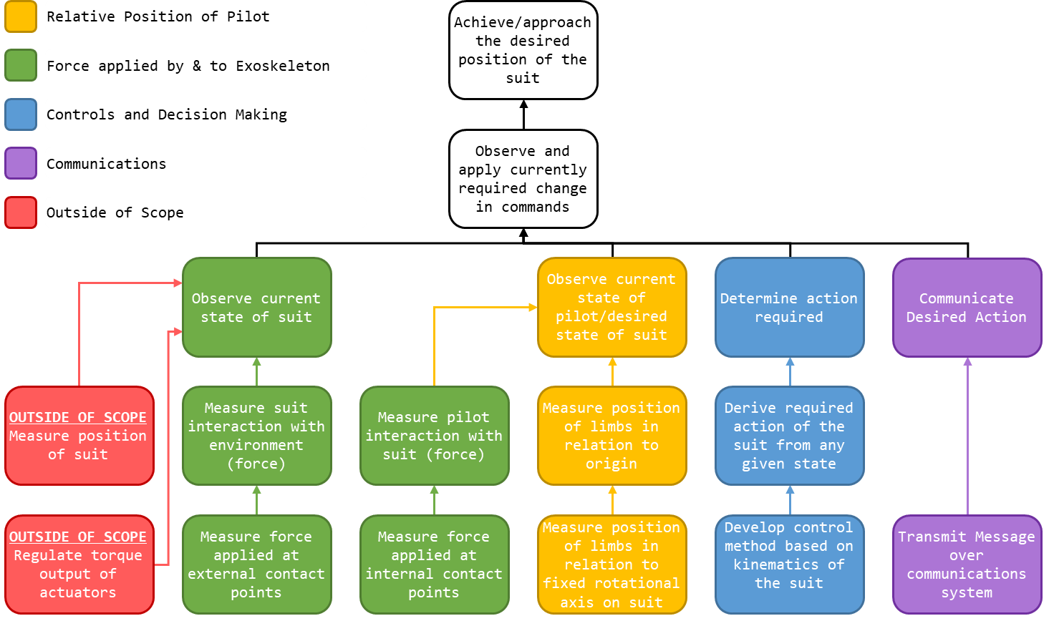

Figure 3; System Decomposition

As seen in Figure 3; System Decomposition, he ultimate goal of the project is that all times the lower extremity exoskeleton will be in the desired position. This may be accomplished by constantly observing the differences between the current state of the system and the desired state of the system and then changing the current system accordingly.

To observe the desired state of the system the position of the pilot and the force applied by the pilot to the exoskeleton must be known.

As seen in Figure 4: Point and Angle to Orientation, the position of a straight linear rod of a fixed length can be described by the relation of a point on the rod (as an angle) to a fixed rotational axis and origin. By observing the angle of a rod relative to an axis we can know the orientation of said rod. Therefore, to determine the current state of the pilot it is possible to observe the location of each limb segment (treated as a straight rod) in relation to a fixed rotation axis.

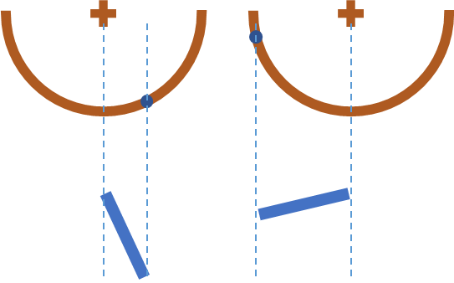

Figure : Point and Angle to Orientation

If the rotational axis of the actuation points of the exoskeleton alight with the rotation axis of each limb segment (assuming the hip, knee, and ankle may be treated as 1 DOF hinges) then the position of each limb in relation to the actuation point may be used to determine the position of each limb. By observing the position of the pilot’s limbs in relation to the suit, it is possible to know where the pilot is positioned (assuming the position of the suit is known).

As stated in 9.4, the pilot may apply force to the internals of the exoskeleton to indicate the desire to increase the force output of the suit. As a result, the force applied to the internals of the suit must be measured. For the representative motions required for a proof of concept; contact is only required with the ground and a seat, therefore the only locations where force output is required is the rear and the soles of the feet. Only knowledge of the force applied to the internals of the suit at contact points is required to maintain control.

By observing the actual state of the exoskeleton, it is possible to determine the changes required to approach the desired configuration of the exoskeleton. The force/torque output of the actuators of the system is consider out of scope, and the position of the actuators and the absolute position of the suit is considered out of scope. However, the force applied by the system to its environments is within scope and must be determined to identify if force output of the exoskeleton should be changed.

For the representative motions required for a proof of concept; contact is only required with the ground and a seat, therefore the only locations where force output is required is the rear and the soles of the feet. Only knowledge of the force applied to the externals of the suit at contact points is required to maintain control.

In order to determine the action required of the system once the state of the pilot and the state of the exoskeleton are known the kinematics of the suit and the system response in a given state must be known.

To communicate between devices and between the actuation and perception/controls systems it is necessary to transmit messages in a predefined format.

# Subsystem One: Relative Position of Pilot

This section details the analysis, design, implementation, and results of the subsystem responsible for the perception of the position of the pilot relative to the exoskeleton.

## Definition and Requirement

The overarching purpose of subsystem one (SS1) was to detect the position of the pilot relative to the position of the exoskeleton in real time. This may be accomplished, as noted in 9.4, by measuring the position of limbs in relation to fixed rotational axis on suit.

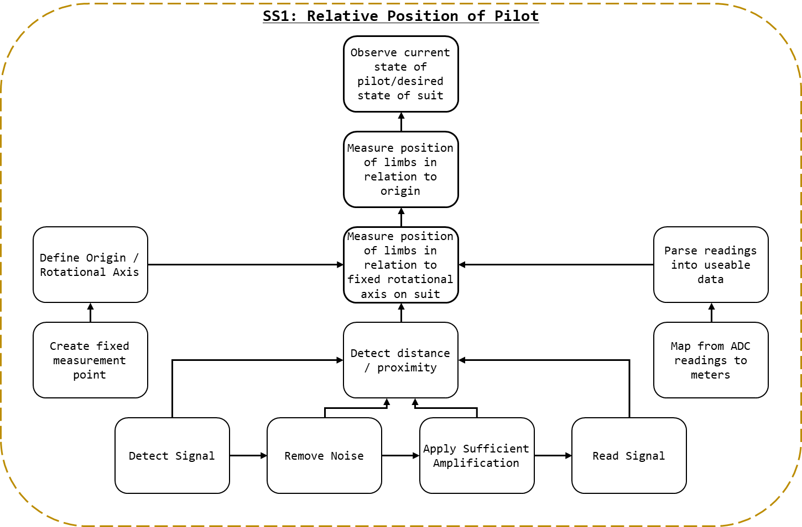

Figure 5: SS1 Breakdown

As detailed in Figure 4: SS1 Breakdown, to measure the position of limbs in relation to fixed rotational axis on suit:

* a fixed rotational axis must be defined;
  + this implies a fixed point where readings can be taken, as such, a mechnism for fastening the detection system must be devised.
* the position/distance must be measured; and,
* the measured distance must be parsed from raw values into useable data.
  + Functionally, this is the process of deriving the function that maps raw analogue voltage values to distance.

The process of measuring the distance will ostensibly entail:

* detecting a signal; the specific type will depend on the techonlogy selected (e.g. IR light, ultrasonic waves, magnetic field strength, etc);
* removing noise from the detected signal; ostensibly through the use of a filter;
* amplifying the cleaned up signal into a range suitble for reading; and,
* reading the signal, ostensibly with an ADC, into a format that can be parsed by the control systems.

## Background and Prior Art

The process of defining the fixed rotational axis and parsing readings into distance values are dictated by the system and are less subject to variation and subjectivity. Instead, the focus on researching prior art for SS1 was determining the most appropriate mechanisms for detecting distance. Additionally, research was conducted on appropriate filtering and amplification methods. The requirements for reading the signals synthesised are outlined, but the selection of a microcontroller for interfacing with all five subsystems is detailed in **Error! Reference source not found.**.

### Perceiving Distance

This section details many of the technology considered for perceiving the proximity of the pilot’s limbs. The sensor types given the most serious consideration are detailed here, with additional sensors types considered found in 22.2.

#### IR Transceiver

Infrared light, or IR, is a form of electromagnetic (EM) radiation general not visible to human eye’s (Lynch & Livingston, 2001). The wavelength of IR is typically defined as ranging from 700 nanometres (frequency 430 THz) to 1 millimetre (300 GHz) (Liew, 2018). IR is emitted by the sun, artificial lighting, fires, as thermal radiation from objects (and animals), and from IR emitters (American Technologies Network Corporation, 2018).

The prototypical IR emitter is a light emitting diode (LED) composed to emit IR when power. They typically share a formfactor with standard LEDs and are often used in IR communication. To receive a signal transmitted via an IR emitter and IR received is used. IR receivers may take the form of a photoresistor configured for IR range light. IR emitters and receivers are often used in concert to transmits a message (via the emitter) and then receive it (via the receiver) (Future Electronics, 2018).

Like all EM waves, IR suffers from attenuation (Garbett, 2001). IR is also capable of being reflected off a non-absorbing material. As seen in Figure 6: IR Proximity Sensing, by emitting IR (A) and measuring the intensity of the light reflected (B) it is possible to determine the distance from the reflective surface (C) and the emitter. This principle may be applied to determine the distance of an object from a transceiver (IR emitter/transmitter and receiver).

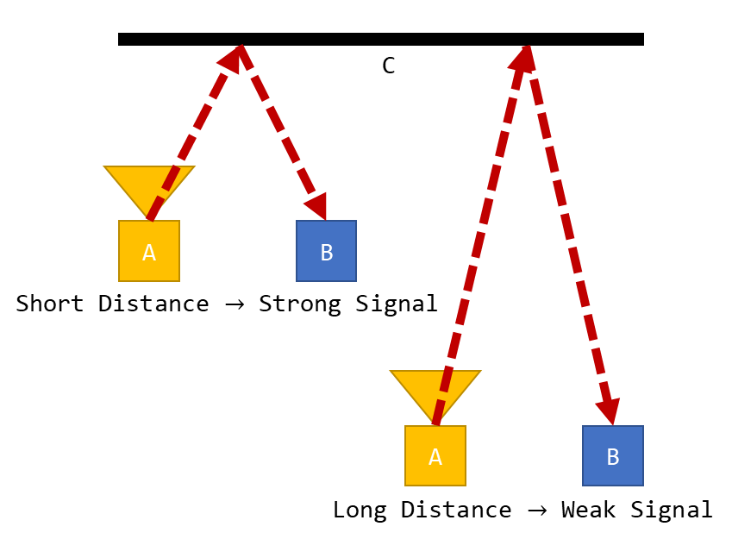

Figure : IR Proximity Sensing

IR is an effective method of detecting range, in fact IR is often employed in LiDAR (Cracknell & Hayes, 2007). Assuming line of sight exists between the reflection point and the IR receiver there is no minimum range. Additionally, IR technology is small, affordable, and ubiquitous. Under ideal conditions an IR transceiver would be capable of perceiving the instance between an exoskeleton and its pilot.

Outside of ideal conditions complications with IR technology can occur. As noted above, IR is ubiquitous and is emitted by the sun, artificial lighting, and animals meaning that even if all undesirable frequencies (e.g. the 38kHz carrier signal from most IR remotes) where filtered from an IR signal noise may still exist. Under poor operating conditions an IR transceiver may be saturated with IR rendering it effectively blind. Additionally, variability in the reflective surface may result in IR being reflected inconsistently or not at all. Under these conditions mapping from signal intensity to distance may be impossible, as different surfaces will yield different signal intensities.

### Filters and Amplification

This section details the theory required for understanding the requirements and design of the filter and amplifier designed for the proximity perception system.

Filters are applied in order to remove noise from a signal, noise defined as “irrelevant or meaningless data or output occurring along with desired information” (Merriam-Webster Dictionary, 2018). An active filter is a filter that uses active components (e.g. operational amplifiers), rather than entirely passive components. Depending on the nature of the noise present in a measured input specific input ranges may need to be filtered (e.g. unwanted frequencies).

A low pass filter is a filter that permits lower frequency signals and filters high frequency noise, with a high pass performing the opposite function. In the case where a specific signal frequency is desired a high pass and a low pass filter may be combined to allow a specific band of frequencies to remain. This configuration is known as a band pass filter.

A common and useful electronic filter topology is the Sallen–Key topology. The Sallen–Key topology is an electronic filter topology that allows for the simple implementation for a second order filter. Seen in kt, a band pass filter may by implemented in Sallen–Key topology.

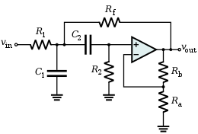

By performing analysis on the circuit depict in figure kt, it is possible to determine the system response of a Sallen–Key bandpass filter.

TALK ABOUT WHAT EQUATIONS WE GET AND HOW THEY CAN BE USED HERE

Kt kt kt

Amplification can be applied to signal to increase its intensity. Within the finite window that is inherent to all measurement mechanisms amplification may be used to increase or decrease the relative signal strength so that the area of interest aligns with the range of measurement. In the context of proximity sensing where the signal intensity may vary (e.g. IR range finding) it may be possible amplify the specific regions on interest. For example, for a signal that ranges between 0-5V for a range of 0-1m being read by and ADC (analogue to digital converter) with a 0-5V range, it may be possible to amplify the signal such that the 10-20cm range constitutes the entire 0-5V range received by the ADC.

## Approach and Execution

### Perceiving Distance

When considering the conditions of operation, the distance perception system was expected to take reading from shifting, rippling, flexing human body parts. Body parts which may be clothed, shaved, hairy, firm, or soft. Body parts with rounded uneven surfaces at close ranges.

The conditions of operation featured many unknowns and the specific approach selected for the actuators could not be known prior to selection of the proximity sensing method (the significant delays would have been untenable). As such, the possibility of acoustic noise in the actuation system or the environment in general could not be dismissed.

Given this understanding of the operating conditions, ultrasonic sensors were considered inappropriate for the creation of a robust design within the constraints of the project.

IR range sensing was selected as the approach for determining distance. The Vishay TCRT5000 - Reflective Optical Sensor with Transistor Output was selected for the IR range sensing (Vishay Semiconductors, 2017), see Figure 5: TRCT5000 (Vishay Semiconductors, 2017). As stated by the manufacturer “The TCRT5000 and TCRT5000L are reflective sensors which include an infrared emitter and phototransistor in a leaded package which blocks visible light. The package includes two mounting clips.” (Vishay Semiconductors, 2017).

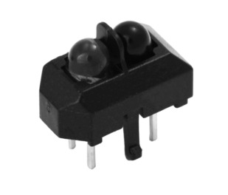

Figure 7: TRCT5000 (Vishay Semiconductors, 2017)

The TCRT5000’s datasheet may be found in the attached documents as “TCRT5000 - Reflective Optical Sensor with Transistor Output.pdf”. The following circuit was used for the configuration of the TRCT5000s within the project, see Figure 6: TRCT5000 Topology, where **SIG** represents the output signal.

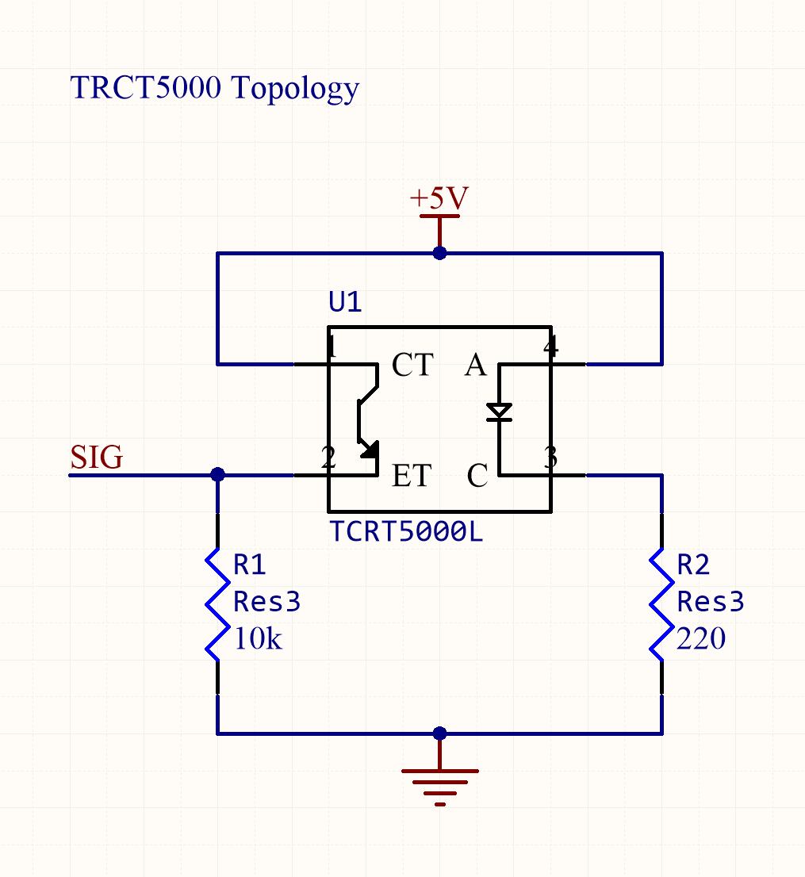

Figure 8: TRCT5000 Topology

A printed circuit board (PCB) would be created to which an IR transceiver, or emitter and receiver, could be mounted. The PCB would be designed as such that it would interface with external systems by only power and signal cables. Ideally, the IR PCB would be modular, and in the case of damage, simply replaced with another like it. This circuit board would feature the circuit in Figure 6: TRCT5000 Topology and the header depicted in Figure 7: IR Sensor Mount Header Topology.

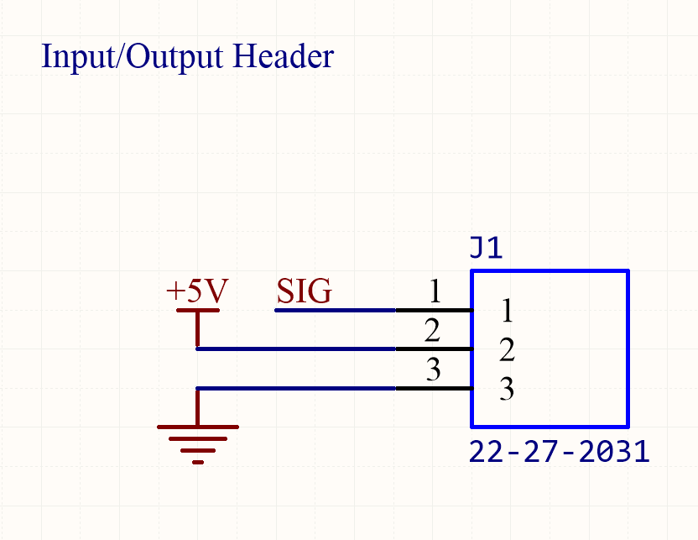

Figure 9: IR Sensor Mount Header Topology

The PCB was designed in Altium Designer (16.1), the PCB schematic may be found in the attached documents under the designation “IR Sensor Mount” and shown in Figure 8: IR Sensor Mount PCB Depiction.

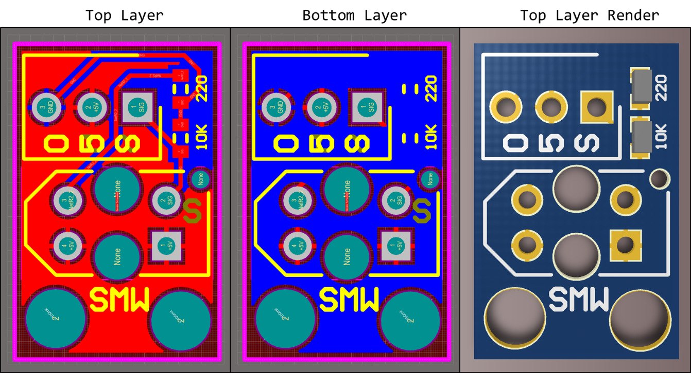

Figure 10: IR Sensor Mount PCB Depiction

The PCBs were fabricated and assembled as shown in Figure 9: Fabricated IR Sensor Mount PCB.

Kt

Figure 11: Fabricated IR Sensor Mount PCB

### Fixed Rotational Axis

The fixed rotational axis upon which distance measurements would be referenced was determined to be the hip, knee, and ankle joints where ostensibly the actuators axis were to be place. As noted in 14, this considerable simplifies the kinematics and controls of the system. However, as the size of the exoskeleton and the limb segments devised was dependent on the mechanical build by those responsible for the actuation system estimations where required for the majority of the project regarding the specific length of limbs.

While it was presumed the exoskeleton’s structural systems would be on the external sides of the pilot’s body, the mounts for the position detection system would be designed without specifies on materials or dimensions of the exoskeleton (these values would remain unconfirmed until exceedingly late within the project).

It could not be presumed that the exoskeleton segments would have free ends, so the system would need to be designed to be attached, firmly, to a rod of an arbitrary shaped cross section of an arbitrary size, without access to a free end. It was required that wobbling vibration, ro movement of any kind was to be minimised and the connection would be remove and reattached an indeterminant number of times. The connection needed to be fast, simple, and not so complicated to introduce risks of improper application.

Hose clamps were identified as a suitable fastener method. Screw/band (worm gear) clamps, see Figure 10: Hose Clamp (Bunnings, 2018), are reusable, can be applied to a rod of an arbitrary shape and size (with ranges), affix firmly, and may be attached quickly with a screwdriver.

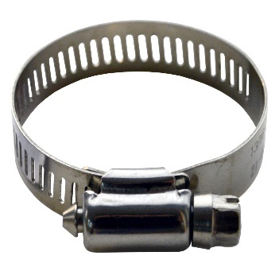

Figure 12: Hose Clamp (Bunnings, 2018)

However, as the details of the proposed exoskeleton became available it was noted that the cross section of exoskeleton frame may have been as small as 5mm in diameter. A size below the range of standard hose clamps. Instead, cable ties were identified as an ideal fastener method.

Seen in Figure 11: Cable Tie (Computer Cable Store, 2018), cable ties, or zip ties are a form of typically plastic ratcheting strap. The can be affixed to a rod of an arbitrary shape and size, attached by hand, and are disposable. While a less permanent solution for an attachment mechanism compared to hose clamps, the were deemed sufficient for a proof of concept.

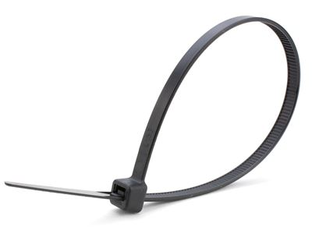

Figure 13: Cable Tie (Computer Cable Store, 2018)

To mount the measurement structure to the exoskeleton a plat was design that could sit flush to the frame. As seen in figure Figure 12: Mount Structure, the structure (black), could be mounted to the exoskeleton frame A. Seen from the side, gutters where placed (B) so cable ties could be affixed, while guard rails (C) ensured the cable ties did not slip or move during operation. The measurement structure and any auxiliary objects could be affixed at the surface of the plate (D) with counterbored sections (E) for nuts and bolts to be mounted while sitting flush with the surface of the exoskeleton.

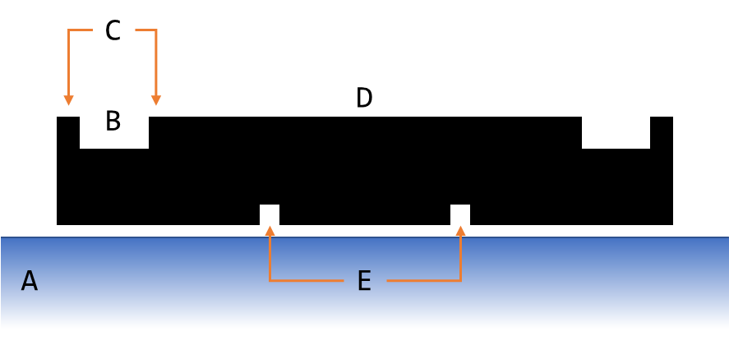

Figure 14: Mount Structure

The component was created in Autodesk Inventor, as seen in Figure 13: Mount Structure (Single) CAD. Attached to this document full CAD files for all components can be found kt.

Kt

Figure 15: Mount Structure (Single) CAD

To minimise the weight of this component and ease in manufacturing, the mounting plate was constructed via 3D printing, see Figure 14: Printed Mount Structure (Single).

kt

Figure 16: Printed Mount Structure (Single)

Presuming a fixed mounting place (as given by the mount structure) a scaffolding structure would be required to mount the IR sensor PCBs in place. After testing the effective range of the IR sensors created it was determined that two sensors working in tandem provided the most reliable measurements of position. Two sensors doubled the effective IR emitted, and given the irregular surfaces of the human body, the readings could be averaged to give a more consistent reading.

In the circumstance of trying to maintain a consistent offset from the pilot, as noted in kt (controls), the goals of the control systems is not to maintain an exact distance from the pilot, but maintain the safe distance on either side of the pilot. Rather than a solution comprised of measuring the pilot and attempting to maintain a specific offset, sensors on either side of the pilot could be used to detect the difference in the offset on both sides.

The design depicted in Figure 15: Sensor Frame was created. The frame (B) would envelope the pilot (A), and attach to the mount structure (F), see Figure 12: Mount Structure, on the outside edge of the pilot. A pair of sensors would detect in tandem (C) on either side the pilot (D), effectively measuring the position of the front and back of their leg in relation to the actuation of the exoskeleton.

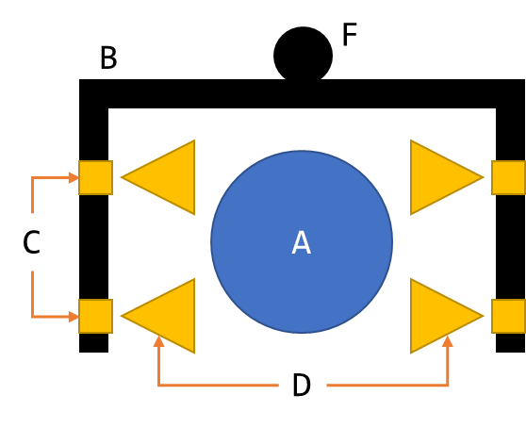

Figure 17: Sensor Frame

As shown in Figure 16: Constructed Sensor Frame, the sensor frame was constructed from aluminium, and later wood. Aluminium was selected for is strength and weight (relative to other metals). Once tested using the rig developed in 16, a lighter material was sought. Wood was selected. While adequate for a prototype, the materials used should be replaced with lighter plastic or carbon fibre materials for future designs; the structural requirements of the system are minimal and weight reduction is a priority.

kt

Figure 18: Constructed Sensor Frame

### Mapping Values

kt

## Results and Discussion

The final system was commissioned and assembled, as shown in Figure 17: Subsystem One (Assembled) .

Figure 19: Subsystem One (Assembled)

How well did it work?

# Subsystem Two: Force applied by and to Exoskeleton

This section details the analysis, design, implementation, and results of the subsystem responsible for the perception of the applied by the exoskeleton to the environment and by the pilot to the exoskeleton.

## Requirements and Functional Decomposition

The overarching purpose of subsystem two (SS2) is to measure the force applied to the internals and externals of the suit.

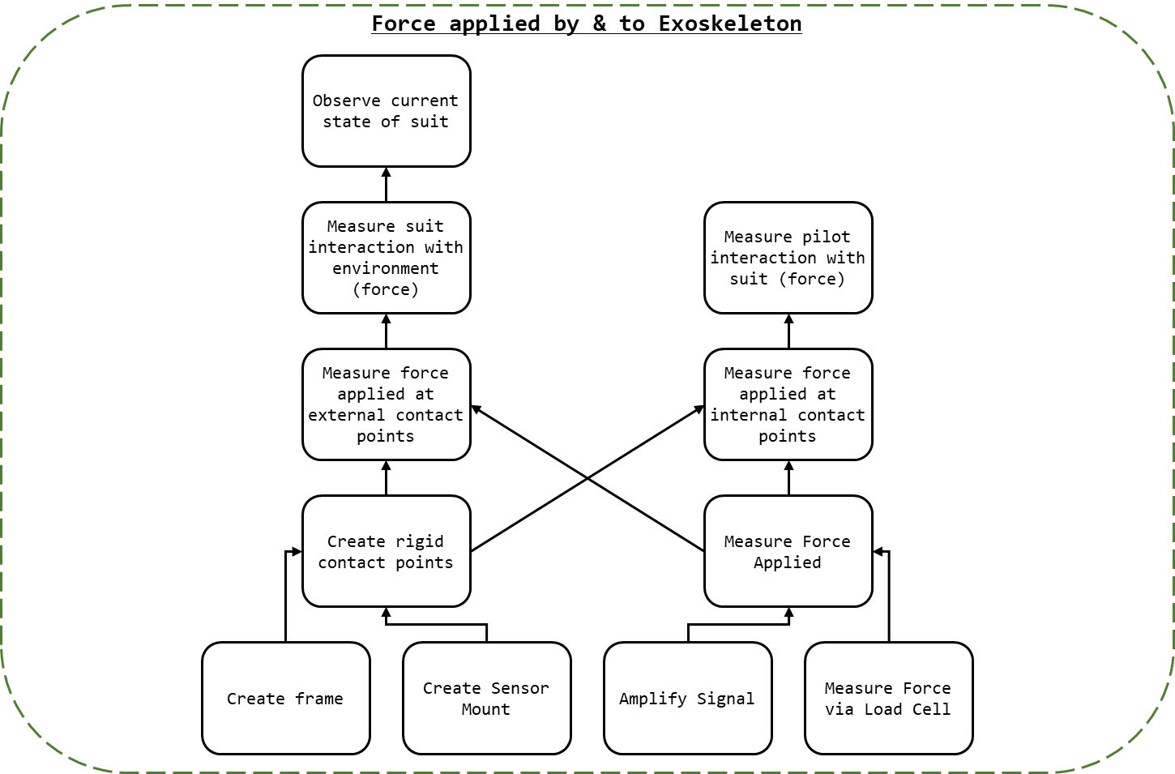

Figure : SS2 Breakdown

To measure the force applied to the suit at the designated contact points (feet and upper thigh) the following was required:

* Creating of rigid contact point upon which force application could be measured;
  + This would require a rigid frame upon which sensors could be mounted; and,
  + Mounts for force sensors.
* Measuring the force applied to the surface; and,
  + This would involve measuring the force applied via load cell; and,
  + Amplifying the signal from the load cells.
* The measured distance must be parsed from raw values into useable data.
  + functionally, this is the process of deriving the function that maps raw analogue voltage values to force.

## Background and Prior Art

### Load Cells

Transducers are “elements that convert from one form of energy to another for example, sound to electricity” (Agarwal, 2005). A load cell is a type of transducer that converts the application of force or pressure into voltage or a change in imprudence. A load cell may be effectively used to measure the force applied to a surface, and the fundamental technology behind the common bathroom scale.

## Approach and Execution

### Measure Force

Load cells would be used to measure the force application to the contact points. Load cells allow for the précised measurement of force application in real time. Given the weight of the individuals associated with the project and preliminary estimations of the exoskeleton mass it was assumed that the mass for the entire system and pilot would not exceed 150 kg. Due to the incrementation of load cell ratings, 200 kg (four 50kg load cells) were selected. As seen in Figure 21: YZC-161B - 50kg Load Cell (ZJIA, 2018), the YZC-161B 50kg (coincidentally the load cell used in bathroom scales) is a flat strain-gauge type load cell specifically rated for human mass measurement.

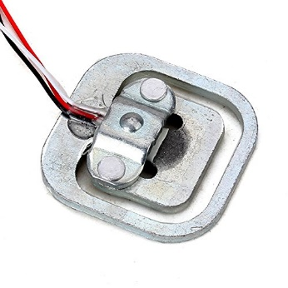

Figure : YZC-161B - 50kg Load Cell (ZJIA, 2018)

The YZV-161B’s datasheet may be found in the attached documents as “YZC-161B - 50kg Load Cell.pdf”. The designation of each wire for the YZC-161B may be found in Figure 22: YZC-161B Wire Configuration.

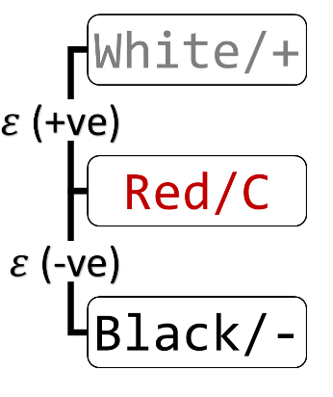

Figure : YZC-161B Wire Configuration

Four YZC-161B were wired in Wheatstone bridge configuration as shown in Figure 22: Load Cell Configuration.

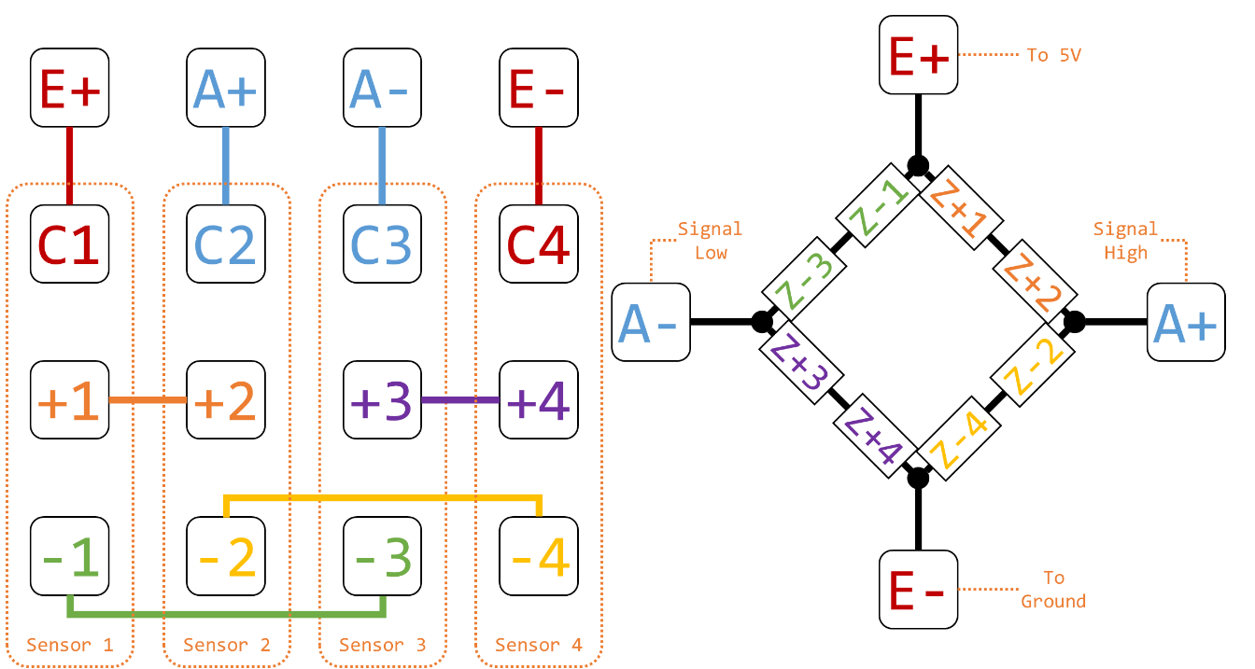

Figure : Load Cell Configuration

The configuration shown in Figure 22: Load Cell Configuration was implement in the PCB design of the controller boards, detailed in kt, in the schematic shown in Figure 23: Load Cell Topology, where B and T refer to the external and internal (bottom and top) load cell sets respectively.

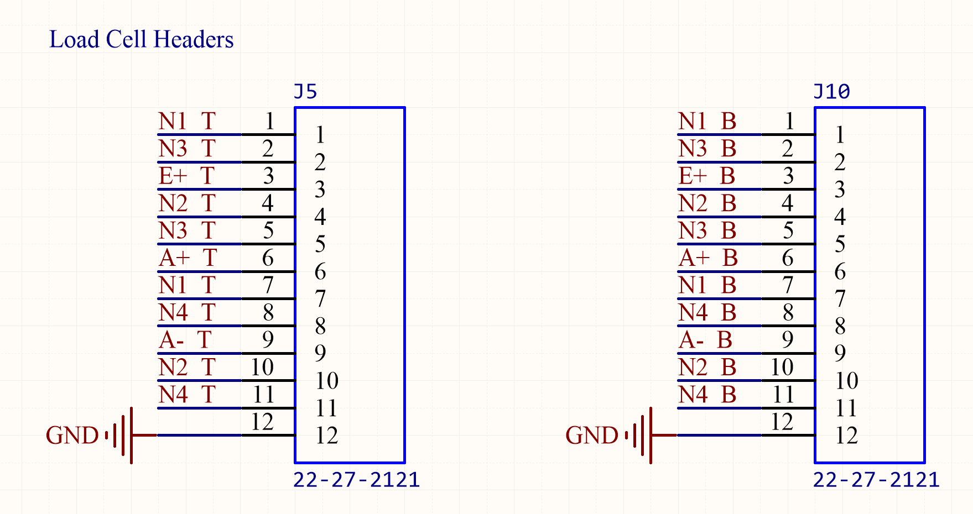

Figure : Load Cell Topology

### Amplify Signal

To measure the signal output by the Wheatstone bridge configuration an instrumentation amplifier was used. The amplifier selected was the INA125, as seen in Figure 25: INA125 - Instrumentation Amplifier.

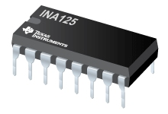

Figure : INA125 - Instrumentation Amplifier

The INA125’s datasheet may be found in the attached documents as “INA125 - Instrumentation Amplifier With Precision Voltage Reference.pdf”. The INA125s in the project were wired as depicted in Figure 26: Load Cell Amplifier Topology.

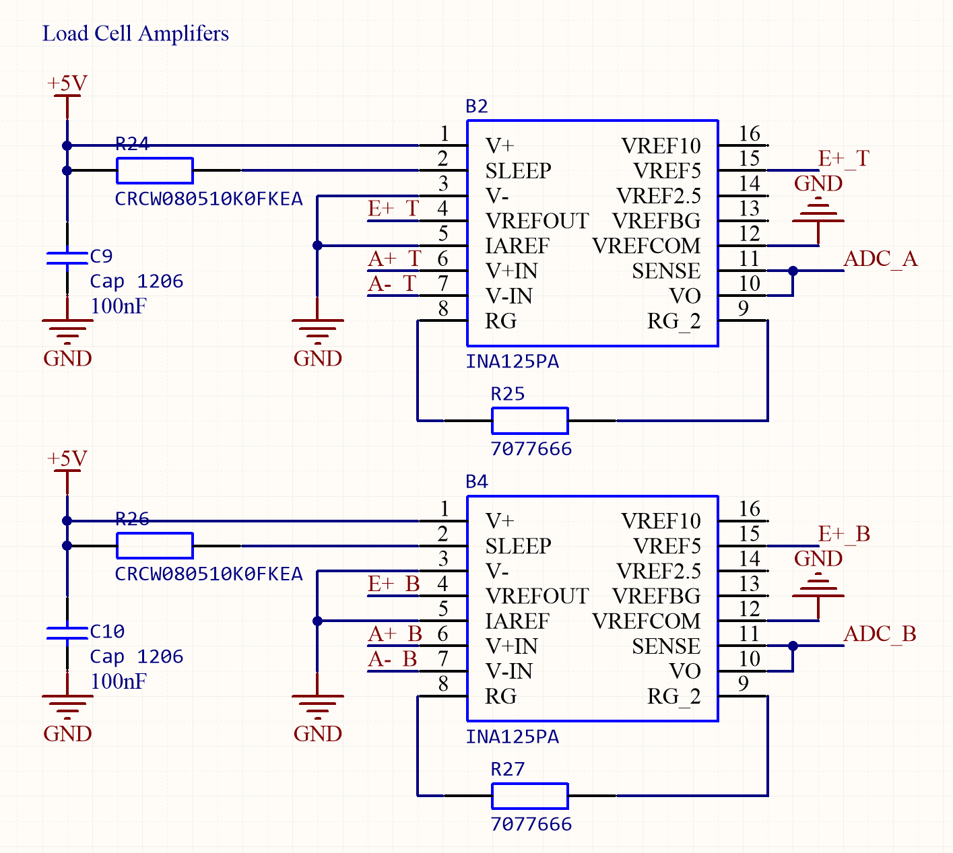

Figure : Load Cell Amplifier Topology

The INA125 allows for adjustable gain determined by the value of , shown as R25 and R27 in Figure 26: Load Cell Amplifier Topology. The gain of the amplifier was

### Mount Sensor

### Rigid Frame

## Results and Discussion

Quality control on the YZC is dogshit

# Subsystem Three: Controls and Decision Making

This section details the analysis, design, implementation, and results of the subsystem responsible for determining the actions required by the actuation system.

## Requirements and Functional Decomposition

Talk about how there ended up being three controls system, theory, position, cont rotation

## Background and Prior Art

## Approach and Execution

## Results and Discussion

# Subsystem Four: Communications

This section details the analysis, design, implementation, and results of the subsystem responsible for communication between the actuation systems and the controls/perception systems.

## Requirements and Functional Decomposition

The overarching purpose of subsystem four (SS4) is to communicate the desired action to the actuation system.

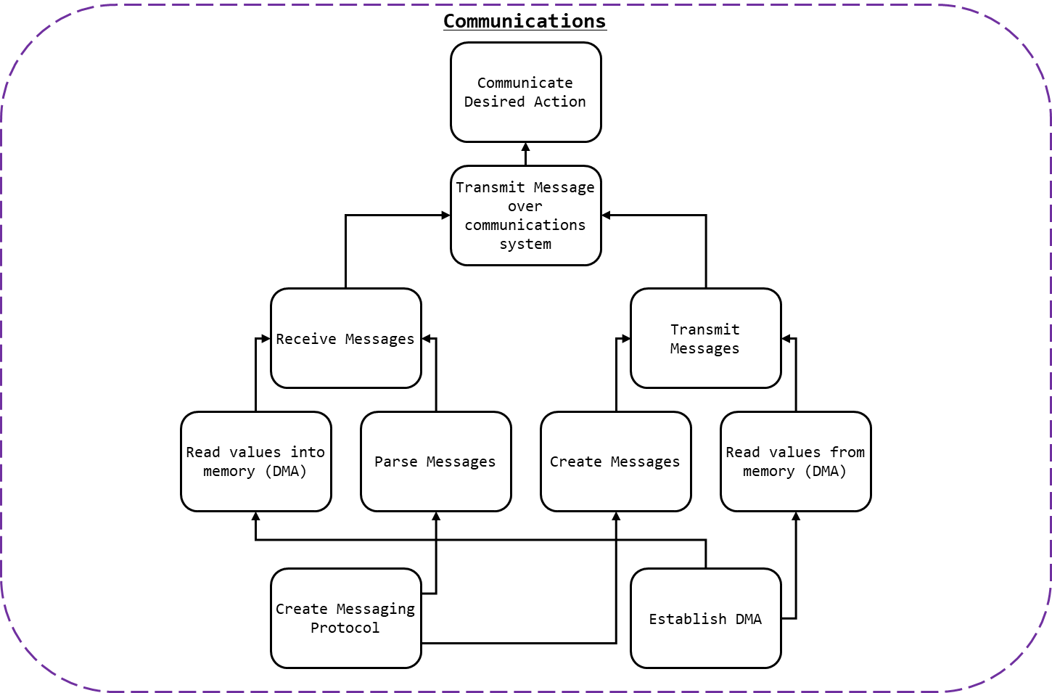

Figure 27: SS4 Breakdown

As detailed in Figure 18: SS4 Breakdown, to communicate the desired action to the actuation system:

* Messages would need to be received; and,
  + This process would involve receiving the messages; and,
  + Parsing them into useable data.
* Messages would need to be sent.
  + This process should involve creating messages; and,
  + Transmitting them.

To ensure that messages where properly interpreted and created by all parties a communication protocol and packet protocol would be need.

To store messages, received or sent, numerous methods were considered and tested. Ultimately, Direct Memory Access (DMA) was used which required that the DMA on the selected microcontroller be enabled.

### Communication Protocol

The requirements of the communication protocol where as follows:

* ASCII messages must be transmittable;
* Synchronisation or dependency between systems is to be avoided;
* Systems which required addresses for communication were to be excluded.

### Packet Protocol

The requirements of the packet protocol where as follows:

* Generic data types must be transmittable;
* Signed values (plus/minus) of either integers or real numbers would be sent; and,
* Start and stop bits characters would be used to indicate the beginning and the end of messages (in the case of incomplete messages, the message should be invalid).

### Connection Method

The requirements of the connection where as follows:

* Wired connection method;
* A common ground should be established (where relevant); and,
* Where possible standardised jacks/sockets should be used.

## Background and Prior Art

Parallel communication is the method of communicating a multibit message over multiple channels. With enough channels, parallel communication may be used to communicate a message of *any* size in a single clock cycle. However, communication channels can be resource intensive (i.e. using lots of cables and pins, the physical size of the interconnect).

Instead serial communication involves sending data over a single channel sequentially. While often slower than parallel communication, serial communication is often preferable due to the scarcity of I/O lines on microcontrollers. A protocol of encoding messages is used to transmit messages in a consistent intelligible manner.

Serial communication may be synchronous or asynchronous. Synchronous uses a clock signal to synchronise communication. This can result in faster more reliable communication but depends on a centralised clock signal; to maximise demarcation between the project sections, synchronous communication shall not be used.

Asynchronous serial communication may be accomplished by the use of a pair of wires (one for transmission, one for receiving) and by transmitting messages in binary. Messages which can be encoded in binary (e.g. ASCII) may be transmitted in this manner.

A universal asynchronous receiver-transmitter (UART) is a hardware device for asynchronous serial communication that may be integrated into a microcontroller. UART may be used to implement asynchronous serial communication on a microcontroller via I/O lines.

Direct memory access (DMA) is a mechanism by which hardware systems (like UART) are able, independent of the central processing unit (CPU), to interface directly with the main system memory. By bypassing the CPU read and write operations can be completed faster, while the CPU is dedicated to other tasks. For example, messages received via UART may be directly stored in memory, and messages to be sent via UART may be loaded into buffers directly.

## Approach and Execution

### Communication Protocol

For details relating to the microcontroller selection see section (kt). As noted in section kt, two communication channels were required per microcontroller.

Two UART channels where implemented in C for the STM32 Nucleo boards. The pin used by each channel is shown in Table 2: UART Pins.

Table 3: UART Pins

|  |  |  |  |  |
| --- | --- | --- | --- | --- |
| UART | Function | STM32F303k8 Pin | Nucleo Connector Pin | DMA Channel |
| UART 1 | RX | Port A Pin 10 | D0 | 5 |
| TX | Port A Pin 9 | D1 | 4 |
| UART 2 | RX | Port A Pin 3 | A2 | 7 |
| TX | Port A Pin 2 | A7 | 6 |

Much of the peripheral initilisation was completed used STM32CubeMX. The configuration file used can be found in kt. The configuration of both UART channels may be found in Table 3: UART Configuration.

Table 4: UART Configuration

|  |  |
| --- | --- |
| Parameter | Value |
| Baud Rate | 9600 Bits/s |
| Word Length | 8 Bits (Including Parity) |
| Parity | None |
| Stop Bits | 1 |
| Alternate Function (for GPIO) | 7 |

Each UART was configured to use DMA to receive and transmit messages. The DMA settings can be found in Table 4: DMA Configuration.

Table 5: DMA Configuration

|  |  |
| --- | --- |
| Parameter | Value |
| DMA Mode | Normal (Not circular) |
| Data Width (Peripheral) | Byte |
| Data Width (Memory) | Byte |
| Increment Address | Memory |
| Priority | Medium |

The process of transmitting a message was as follows:

* Ensure UART 1 and 2 were ready for transmission;
  + Via isTransmitting, which may be found in /Src/main.c
* Load message into buffer; and,
* Direct UART to transmit buffer via DMA.
  + Via HAL_UART_Transmit_DMA, which may be found in /Drivers/STM32F3xx_HAL_Driver/Src/stm32f3xx_hal_uart.c

### Packet Protocol

As seen in Figure 19: Packet Protocol, a packet protocol was established to ensure that messages could be understood.

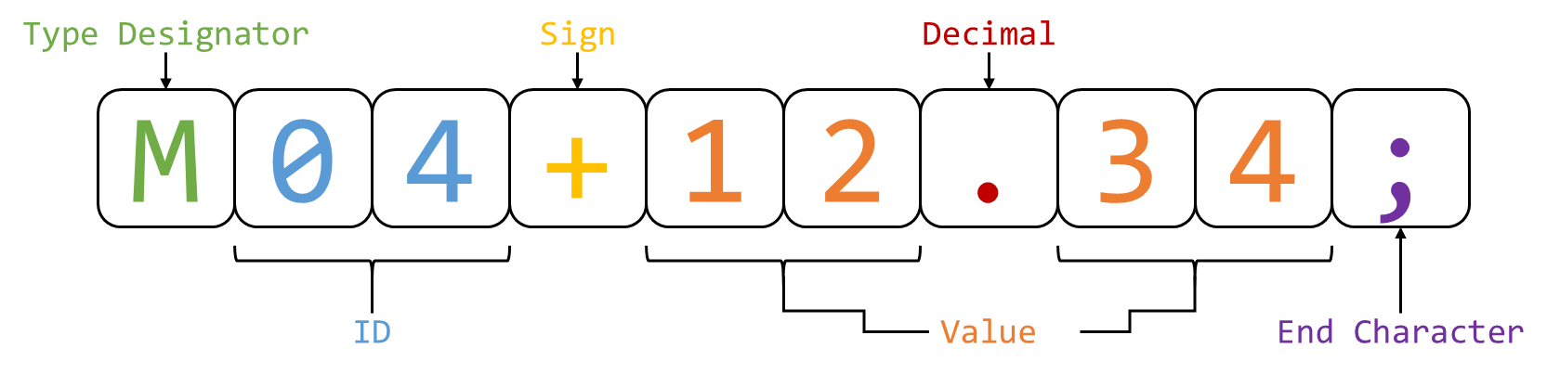

Figure 28: Packet Protocol

The protocol is detailed in Table 5: Packet Protocol:

Table 6: Packet Protocol

|  |  |
| --- | --- |
| Value | Notes |
| Type Designator | The non-case-sensitive type designator indicated what type of value was being transmitted. For example, ‘T’ (or ‘t’) indicated that the value represented the desired torque of an actuator. Size: 1 char |
| ID | The integer representing which value of a given type was being updated. For example, an ID of 03 referred to the right foot. Size: 2 chars |
| Sign | Used to indicate if the value was positive or negative. Size: 1 char |
| Value | The value being updated. This could be of any length. A left-hand side and right-hand side value (even if 0) was required for a valid message (e.g. 11 or .5 was invalid, but 11.0 and 0.5 was valid. |
| Decimal | Used to punctuate the value received. Indicated the end of the left-hand side of the value. Size: 1 char |
| End Character | Used to indicate the end of a message. Upon reading a valid message this value would be changed to an ‘@’ to prevent the same message (within the DMA buffer) from being ready twice. Size: 1 char |

This protocol was used for all communicates to, from, and within the controls/perception system.

### Connection Method

As UART was to be used over a two-wire connection three wires in total were required:

* RX;
* TX; and,
* Ground.

A common ground ensures that all RX an TX messages where read correctly and had the same reference voltage. While numerous cable options where viable, Category 5 cable, or CAT 5, cables where selected to connect devices together.

CAT 5 cables are twisted pair cables (4 sets) commonly used in ethernet connection. CAT 5 cable were terminated with 8P8C modular connectors and plugged into female RJ45 connectors. As CAT 5 cables feature more than three wires it became possible to provide 5V across boards, this is discussed in further detail in kt. These connectors were then mounted on the controller PCB, see kt.

## Results and Discussion

SS4 was tested by daisy chaining multiple controller boards together via 1.5m CAT 5e cables. Each board would transmit the messages relevant to it on both UART 1 and UART 2. Messages received would be parse. Invalid messages were discarded. Valid messages where then passed along the chain to ensure all controller boards were informed, e.g. valid messages incoming to UART 1 were sent outgoing to UART 2.

For the thesis demonstration, two boards where connected and sensor readings from one board were used to communicate actuator commands to the other.

In both these test case the communication system was perfectly functioning. Messages were sent and transfer, no corrupt messages were interpreted as valid, and messages where interpreted correctly.

The interface between the actuation system and the controls/perception system was never completed. Provisions were made for connection to another system (these were also used for debugging), see kt, but were tested as the actuation system was never completed. While one can be confident that the communication system would function as required, it cannot be said for certain without testing.

### Communication speed

It is difficult to say if the communication system would have been fast enough to allow for real time control of the system. While messages were kept short and DMA was employed to speed messaging the baud rate of 9600 may have been simply too low for the communication speeds required.

Given an 8-bit char (ASCII character) approximately 109 messages (of standard size) could be sent per second, or about 9ms per message. Given the potential for a message to be passed on up to 6 times before being interpreted by the actuation system, and that up to 5 messages may be queued to be sent by each controller, a maximum delay of 192ms (21 message periods) could be expected. Given a human reaction time of 150 – 300ms (Yuhas, 2012), a system with a reaction time of 192ms will lag behind the user and not react sufficiently quickly.

Going forward it is recommended that the baud rate of the system is raised to 115200 bits/s. Transmitting messages twelve times faster will result in a reaction time of 16ms and reduce the possibility of lag.

# Subsystem Five: Actuation Systems

This section details the analysis, design, implementation, and results of the subsystem responsible for interfacing and actuating actuators to demonstrate the functionality of the other major subsystems.

## Requirements and Functional Decomposition

The overarching purpose of subsystem five (SS5), in lieu of the final exoskeleton actuator system, is to demonstrate the functionality of the other subsystems (and the project in general).

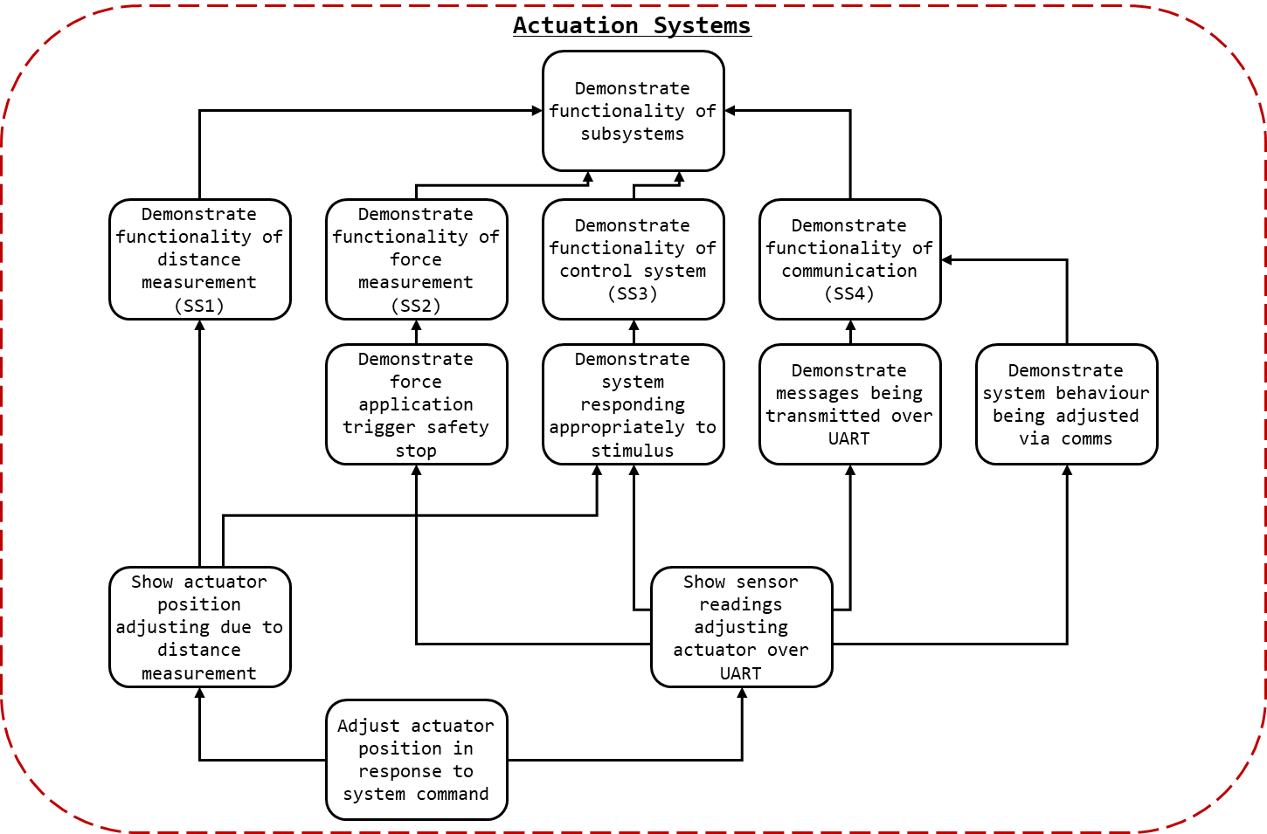

Figure 29: SS5 Breakdown

As detailed in Figure 20: SS5 Breakdown to demonstrate the functionality of the other major subsystems two representative action sets can be completed. The functionality of SS2,3, and 4 can be demonstrated by showing that force sensors readings from one device can, over the communication system, can shut off the operation of an actuator when the external force exceeds the internal force. The functionality of SS1 and 3 can be shown by demonstrating that the position of an actuator can be controlled by position sensor readings.

The functionality of both these tests however, is dependent on the behaviour of an actuator as directed by the system. The reason for two tests, rather than a single integrated test was a consequence of servomotor lead time, as noted in kt.

## Background and Prior Art

### Servomotor

A servomotor is a linear or rotary actuator with a closed-loop control system used to manage its behaviour. Usually a motor will be paired with an encoder to provide feedback to the system. The specific of the implementation of servomotors vary, as does their ability to control position, velocity, and acceleration.

### Pulse Width Modulation (PWM)

Pulse-width modulation (PWM) is a modulation technique most commonly used to encode and control the power output of motors. PWM works by toggling the output signal to a load sufficiently quickly to approximate analogue behaviour. I.e. in a system where power cannot directly be controlled, PWM can be used to ensure that the output signal is high 50% of the time, effectively demanding 50% power to be supplied. As long as the switching frequency is so high as for the resultant waveform to be perceived as continuous the load will behave as if driven by a continuous supply.

For the control of servomotors PWM is often used to indicate the desired behaviour (indicating position, speed, etc…). The signal delivered to the servomotor will be held low and then toggled high for a duration. The duration of the high period, or pulse, in relation to a full cycle period is the duty cycle. The duty cycle indicates to the servo the desired behaviour, see kt.

## Approach and Execution

### Actuators

Due to the time constraints associated with creating SS5 and the goal of demonstrating SS1-4 (not creating a functional exoskeleton), rather than creating a servomotor a prefabricated servomotor was selected as the desired actuator for SS5.

As the lead time associated with most high precision servomotors was beyond the remainder of the project when SS5 was commissioned (in response to learning there would be no exoskeleton) the selection of servomotors available to the project was limited. As such, there were no servomotors available capable of actuating with the force sensor plate attached (the torque requirements were simply too high).

For demonstrating the efficacy of the position system, the strongest servomotor available (by torque) was selected. Greater torque would allow for greater control authority when accelerating, and as the mock exoskeleton (see kt) would be constructed from suboptimal materials greater control authority was a priority. Thus, the MG995 servomotor was selected, see figure kt.

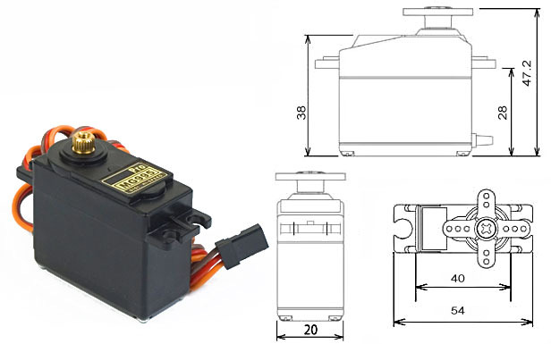

Figure 30: MG995 - High Speed Metal Gear Dual Ball Bearing Servo

The MG995 datasheet may be found in the attached documents as “MG995 - High Speed Metal Gear Dual Ball Bearing Servo.pdf”. The MG995 offered position-based control and 0.98 Nm (10 kgf cm) of torque (at 6V).

For demonstrating the efficacy of the force detection systems a continuous rotation servo was selected as it could stop when the external force on the suit exceeded the force internal, and could vary its speed depending on the force applied internally. Due to its availability the 900-00008 Continuous Rotation Servomotor was selected.

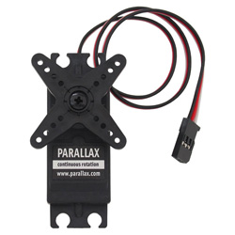

Figure 31: 900-00008 - Continuous Rotation Servo

The 900-00008 datasheet may be found in the attached documents as “900-00008 - Continuous Rotation Servo.pdf”.

To power and control the servomotors a PWM generated by the nucleo boards was used. As the PCBs designed, see kt, did not consider SS5 within scope at the time of fabrication, there were no dedicated headers for powering the servo. Later iterations remedied this by adding a dedicated servo header. For creating the configurations discussed in SS5 fly-wires were solder to the board, and the connections were heat shrunk, see kt. While this is suboptimal, it did allow for reliable and consistent control of the servomotors.

### Test A: Position detection

The first test, to demonstrate SS1 and SS3, would entail attaching the position detection system to a rod at the end of a servomotor and controlling the motor/rod position based on the position readings. Effectively a two-limb-segments/one-joint mock exoskeleton.

As seen in Figure 23: Test A Configuration, A fixed exoskeleton segment (A) is installed flush with a pilot limb segment (B) (e.g. thigh, bicep). At the joint and actuator (S) is used to rotate a free exoskeleton segment (C) flush and parallel to a limb segment of the pilot (D) (e.g. shin, forearm). The IR sensor frame (E) is mounted to the end of C and IR sensors (F) may determine the position of D.

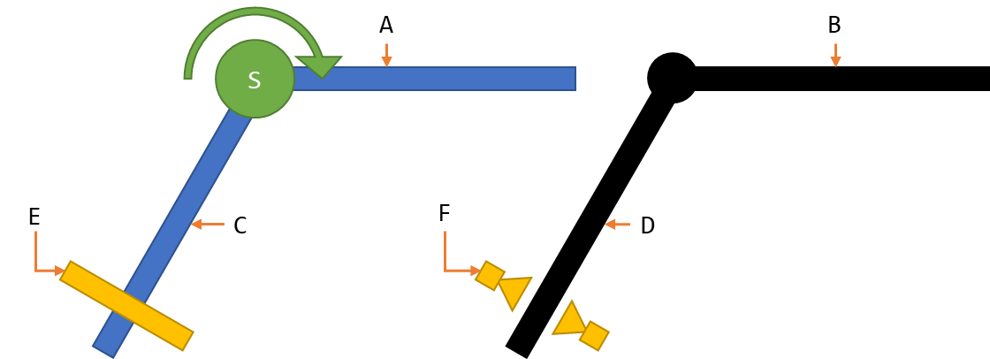

Figure : Test A Configuration

The MG995, discussed in kt, was used as the actuator for Test A. Aluminium beams ( x mm) kt were used for the exoskeleton segments. To minimise the weight of the perception system, the power supply for the servo, SS1, and SS3 where located on the upper segment. Additionally, the controls board was also located on the upper segment.

To mount the lower segment to the servomotor, cable ties were used to attach the segment to a servo horn. A bolt hole placed in the segment was then used to screw the servo horn, servomotor, and segment together, see kt.

### Test B: Force detection

The second test, to demonstrate SS2, SS3, and SS4, would entail connecting two boards via CAT 5e cables. As seen in Figure 24: Test B Configuration, one board (B) would send force measurements from SS2 (A) over the SS4 (C) and the other (D) would control an actuator (S) based on the received values.

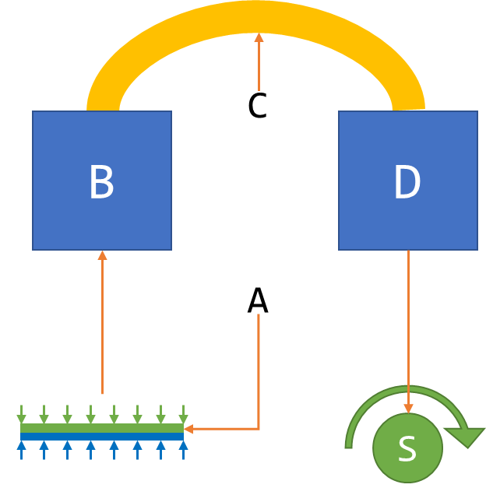

Figure : Test B Configuration

A single short aluminium beam ( x mm) kt was used as a platform for the test. Both boards were mounted to the beam. A CAT 5e cable was used to connect the two boards together.

### PWM Control

To control the servomotors PWM control was required.

For details relating to the microcontroller selection see section (kt).

A single PWM output channel was implemented in C for the STM32 Nucleo boards. Much of the peripheral initialisation was completed used STM32CubeMX. The configuration file used can be found in kt. The configuration of the PWM, including GPIO used, can be found in Table 6: PWM Configuration.

Table : PWM Configuration

|  |  |
| --- | --- |
| Parameter | Value |
| STM32F303k8 Pin | Port B Pin 4 |
| Nucleo Connector Pin | D12 |
| Timer | 3 |
| Channel | 1 |
| Prescaler (PSC - 16 bits value) | 72 |
| Counter Mode | Up |
| Counter Period (AutoReload Register - 16 bits value ) | 100 |
| Internal Clock Division (CKD) | No Division |
| Auto-reload preload | Disabled |
| PWM Generation Channel 1 Mode | PWM Mode 1 |

Once the PWM was initialised, the following methods was required for control:

* Start the PWM (HAL_TIM_PWM_Start(&htim3, TIM_CHANNEL_1))
* Determine Duty Cycle (volatile int DC;)
* Updated desired pulse width (set_pulse_width(void))
* Set the new pulse width & duty cycle, (__HAL_TIM_SET_COMPARE(&htim3, TIM_CHANNEL_1, pulse_width);

This could be used to control behaviour of the motors given the configuration, see Table 7: Motor PWM Requirements.

Table : Motor PWM Requirements

|  |  |
| --- | --- |
| Test A (MG995) |  |
| Cycle Period | 20 ms (50 Hz) |
| Min Pulse (-60 Deg) | 0.7 ms |
| Max Pulse (+60 Deg) | 2.5 ms |
| Idle Pulse (0 Deg) | 1.5 ms |
|  |  |
| Test B (900-00008) |  |
| Cycle Period | 20 ms (50 Hz) |
| Min Pulse (-50 rpm) | 1.3 ms |
| Max Pulse (+50 rpm) | 1.7 ms |
| Idle Pulse (0 rpm) | 1.5 ms |

## Results and Discussion

This section will detail the performance of the actuators selected and their interface with the supersystems. For discussion relating to the systems performance in Test A and Test B see section kt.

To summarise the results of SS5, it works but its ugly. We begin with the ugly.

The attachment mechanism for mounting associated with the servomotors depended on cable ties. While cable ties are perfectly adequate for cable management, and function well as a stand in for hose clamps at small diameters, they are not a robust or rigid method of fasting motors in place. In further iterations of the system it is strongly recommended that dedicated mounts for the servomotors be commissioned.

The exoskeleton segments, comprised of aluminium, were heavy and flexible. In Test A, a finger’s touch could cause the lower exoskeleton segment to wobble and flex. The system when tested would oscillate if accelerated too quickly, confusing the perception systems. This effectively capped the accuracy of the perception system and the speeds (and response times) at which stability could be attained.

Motor selection should not be determined by lead time. Instead actuators should be selected based their requirements. Originally the 900-00008 was to be used for Test A, but upon preliminary testing it was found that it lacked the torque to lift the lower exoskeleton segment beyond 30 degrees.

Neither servomotor allowed for control via torque or acceleration, the control variable used in SS3. Instead position and velocity were controlled. However, they could not be measured so the acceleration could not be indirectly controlled. The servomotors had their own internal control mechanisms, which had to be compensated for. Finally, the resolution of the MG995 was so low as to be visually perceptible. For all further iteration of the system it is strongly suggested that the actuators be reengineered.

Soldering loose cables to the through holes of a PCB header to control a system’s actuators is… not best practice. While later iterations of the PCB included dedicate servo headers, the PCBs used for demonstration featured fly-wires.

The battery system used for SS5 was functional but ramshackle. An 8-battery receptacle was modified to fit 4 batteries to power the 6V MG995. This should be replaced with a 4-battery receptacle.

Preferential to the improvements discussed SS5 should be make redundant. ***A functioning actuation and structural system would eliminate the need for SS5 entirely***.

Areas of possible improvement considered, SS5 as a whole worked, and performed as desired.

Analysis via logic analyser indicated that the PWM generation worked correctly in all circumstances. The PWM implemented worked correctly in all circumstances it was tested. The code developed was effective and functional.

The motors when testing in isolation or in Test A and Test B performed as instructed. While the response time of the MG995 was slower than preferred, it was adequate to demonstrate the functionality of perception systems.

# Integrated Exoskeleton

This system details the process of integrating the engineered solutions of the major subsections of the project. Then the final holistic system commissioned is detailed.

## Requirements and Functional Decomposition

## Prior Art

## Solution

## Implementation

A “Signal, Voltage High, Ground” standardisation was placed on all inputs and ouputs as best practice for the entire project.

3.3 holes, 3.5mm drill bit, M3 screws

Powering devices via ethernet

## Results

# Results and Performance

# Recommendations and Further Works

## SS1

* Use hose clamps

## SS2

## SS3

## SS4

## SS5

## Exoskeleton

# Conclusion

# Bibliography

Agarwal, A. (2005). *Foundations of analog & digital electronic circuits* (1 ed.). Massachusetts: Massachusetts Institute of Technology. Retrieved June 1, 2018, from https://www.google.com/url?sa=t&rct=j&q=&esrc=s&source=web&cd=1&ved=0ahUKEwiBu7yQl7LbAhUEoZQKHfYlBzkQFggpMAA&url=http%3A%2F%2Fsiva.bgk.uni-obuda.hu%2Fjegyzetek%2FMechatronikai_alapismeretek%2FEnglish_Mechatr%2FElectr_Eng-1%2FLiterature%2FFoundations%2520o

American Technologies Network Corporation. (2018, May 30). *How Does Night Vision Work*. Retrieved from atncorp.com: https://www.atncorp.com/hownightvisionworks

Arrow. (2018). *Magnetoresistive Sensor.* Retrieved May 30, 2018, from arrow.com: https://www.arrow.com/en/categories/sensors/magnetoresistive-sensors

Axe, D. (2012, May 23). *Combat Exoskeleton Marches Toward Afghanistan Deployment*. Retrieved May 30, 2018, from Wired: https://www.wired.com/2012/05/combat-exoskeleton-afghanistan/

Bulgrin, M. (2017, May 11). *The History of the Hose Clamp.* Retrieved from normagroup.com: https://blog.normagroup.com/en/the-history-of-the-hose-clamp/

Bunnings. (2018, May 31). *Kinetic 21 - 44mm 304 Stainless Steel Hose Clamp.* Retrieved May 31, 2018, from Bunnings.com: https://www.bunnings.com.au/kinetic-21-44mm-304-stainless-steel-hose-clamp_p4920194

Charara, S. (2015, July 9). *This robotic exoskeleton helps paralysed patients to walk and it's getting smarter*. Retrieved August 23, 2017, from Wearable: https://www.wareable.com/wearable-tech/exoskeleton-paralysed-patients-ekso-bionics-gt-sarah-thomas

Computer Cable Store. (2018, May 31). *11 7/8 Inch Black Standard Nylon Cable Tie - 100 Pack.* Retrieved May 31, 2018, from computercablestore.com: https://www.computercablestore.com/11-78-inch-black-standard-nylon-cable-tie-100-pack

Cornwall, W. (2015, October 15). *Feature: Can we build an ‘Iron Man’ suit that gives soldiers a robotic boost?* Retrieved August 20, 2017, from sciencemag.org: http://www.sciencemag.org/news/2015/10/feature-can-we-build-iron-man-suit-gives-soldiers-robotic-boost

Cracknell, A. P., & Hayes, L. (2007). *Introduction to Remote Sensing* (2 ed.). London: Taylor and Francis. Retrieved May 30, 2018

Cutnell, J. D., & Johnson, K. W. (1998). *Physics* (4th ed.). New York: Wiley.

Cyberdyne. (2015, August 1). *CYBERDYNE Inc. has begun seeking approval from the U. S. Food and Drug Administration (FDA)*. Retrieved August 23, 2017, from cyberdyne.jp: https://www.cyberdyne.jp/english/company/PressReleases_detail.html?id=1075

Cyberdyne. (2016). *What’s HAL?* Retrieved August 19, 2017, from cyberdyne.jp: https://www.cyberdyne.jp/english/products/HAL/

Cybernetic Zoo. (2010, October 14). *1890 – Assisted-walking Device – Nicholas Yagn (Russian)*. Retrieved May 30, 2018, from Cyberneticzoo.com: http://cyberneticzoo.com/tag/nicholas-yagn/

Cybernetic Zoo. (2010, April 10). *1965-71 – G.E. Hardiman I Exoskeleton – Ralph Mosher (American)*. Retrieved May 30, 2018, from cyberneticzoo.com: http://cyberneticzoo.com/man-amplifiers/1966-69-g-e-hardiman-i-ralph-mosher-american/

Dunietz, J. (2017, July 27). *Robotic Exoskeleton Adapts While It’s Worn*. Retrieved August 20, 2017, from scientificamerican.com: https://www.scientificamerican.com/article/robotic-exoskeleton-ldquo-evolves-rdquo-while-its-worn/

Future Electronics. (2018, May 30). *What is Optoelectronics?* Retrieved from Future Electronics: http://www.futureelectronics.com/en/optoelectronics/infrared-receivers.aspx

Garbett, I. (2001, Janurary 1). *Light attenuation and exponential laws*. Retrieved May 30, 2018, from plus.maths.org: https://plus.maths.org/content/light-attenuation-and-exponential-laws

Gross, K. (2018, Feburary 19). *Ultrasonic Sensors: Advantages and Limitations*. Retrieved May 30, 2018, from MaxBotix: https://www.maxbotix.com/articles/advantages-limitations-ultrasonic-sensors.htm/

Jackson, R., Green, K. R., & Eisenbeis, R. (2017). *Achieve greater precision, reliability with integrated magnetic sensing technology.* Retrieved May 30, 2018, from ti.com: http://www.ti.com/general/docs/lit/getliterature.tsp?baseLiteratureNumber=sszy030&fileType=pdf

Karlin, S. (2011, July 29). *Raytheon Sarcos’s Exoskeleton Nears Production*. Retrieved August 11, 2017, from spectrum.ieee.org: http://spectrum.ieee.org/at-work/innovation/raytheon-sarcoss-exoskeleton-nears-produc

Keller, M. (2016, August 25). *Exoskeleton - Do You Even Lift, Bro? Hardiman Was GE’s Muscular Take On The Human-Machine Interface*. (General Electric) Retrieved May 30, 2018, from GE Reports: https://www.ge.com/reports/do-you-even-lift-bro-hardiman-and-the-human-machine-interface/

Keyence Corporation. (2018). *What is a Inductive Proximity Sensor?* Retrieved May 30, 2018, from keyence.com: https://www.keyence.com/ss/products/sensor/sensorbasics/proximity/info/

Liew, S. C. (2018, May 30). *Electromagnetic Waves*. Retrieved from Centre for Remote Imaging, Sensing and Processing.: https://crisp.nus.edu.sg/~research/tutorial/em.htm

Lynch, D. K., & Livingston, W. C. (2001). *Color and Light in Nature* (2nd ed.). Cambridge, United Kingdom: Cambridge University Press. Retrieved May 30, 2018, from https://books.google.com.au/books?id=4Abp5FdhskAC&pg=PA231&redir_esc=y#v=onepage&q&f=false

Merriam-Webster Dictionary. (2018, May 18). *noise*. Retrieved May 30, 2018, from merriam-webster.com: https://www.merriam-webster.com/dictionary/noise

Robomart. (2015, November 9). *Advantages and Disadvantages of ultrasonic distance sensor.* Retrieved May 30, 2018, from Robomart: http://roboticsensors.blogspot.com/2015/11/advantages-and-disadvantages-of.html

Texas Instruments Incorporated. (2017). *Hall effect sensors*. Retrieved May 30, 2018, from ti.com: http://www.ti.com/sensing-products/magnetic-sensors/hall-effect/overview.html

Thomas Publishing Company. (2018). *Capacitive Proximity Sensors*. Retrieved May 30, 2018, from Thomas: https://www.thomasnet.com/articles/instruments-controls/proximity-sensors

Vishay Semiconductors. (2017, February 8). TCRT5000 - Reflective Optical Sensor with Transistor Output.

Yagin, N. (1890, February 11). *United States of America Patent No. 440684.*

Yuhas, D. (2012, May 24). *Speedy Science: How Fast Can You React?* Retrieved from scientificamerican.com: https://www.scientificamerican.com/article/bring-science-home-reaction-time/

# Appendices

## Representative Movements

### Level One Functionality: Standing

To stand while the exoskeleton system is engaged requires the system to be capable of achieving equilibrium and control in a static environment.

Level one functionality demonstrates that for an instantaneous snapshot of operation that the system is capable of regulated operation. Note, level one functionality may also highlight the system’s ability to compensate for steady state error.

### Level Two Functionality: Squatting

Level two functionality requires level one functionality.

To squat while the exoskeleton system is engaged requires the system to be capable of control in a dynamic environment where the pilot is moving. A squat allows for the pilot to engage in motion at the stable pace of the exoskeleton, and as such may non-real-time operations.

Level two functionality demonstrates that the system is capable on a fundamental level of mirroring the pilot’s movements.

### Level Three Functionality: Stair Climbing

Level three functionality requires level two functionality.

To climb up stairs while the exoskeleton system is engaged requires the system to be capable of control in a dynamic environment where the pilot is moving while also applying force to the environment. However, should the system apply too much force to the environment the exoskeleton will simply lift itself off the ground, ultimately not requiring meaningful force regulation.

Level three functionality demonstrates that the system is capable of applying force to an environment.

### Level Four Functionality: Sitting

Level four functionality requires level three functionality.

To sit down while the exoskeleton system is engaged requires the system to be capable of control in a dynamic environment where the pilot is moving while also applying force to the environment in a regulated manner. If the suit applied too great a force to a seat, then it may damage the seat. If the system is incapable of allowing the user to rest on the system, it may result in uncontrolled behaviour. As the pilot sits the system should concede to the force applied by the seat, until the point at which the plot applies force to the upper thighs of the system.

Simply, if a suit is capable of sitting, it is capable of interacting with the environment without destroying. Level four functionality demonstrates that the system is capable of applying force to an environment in a safe and regulated manner.

### Level Five Functionality: Standing/Walking/Sprinting

Level five functionality requires level four functionality.

Presuming all prior levels of functionality are attained the suit should be capable of all required actions. However, to switch contexts and move between standing, moving, and running actions requires dynamic real time control. For an exoskeleton system to be truly viable, it is essential that context switching, and real time control are possible.

Level five functionality demonstrates that the system is capable of acting in a real environment and acts as a complete proof of concept for position-based control methods.

## Unsuitable Proximity Sensors

#### Ultrasonic Range Finders

Ultrasonic waves are sound waves with a frequency above the audible range of humans, approximately 20 kHz (Cutnell & Johnson, 1998). Ultrasonic waves can used for range finding by emitting an ultrasonic sound and recording the time for the wave to be reflected back. Ultrasonic range finders have been used as the autofocus in cameras, and motion detectors, and are the underlying technology for Sonar.

Ultrasonic ranger sensors have the advantages of (Gross, 2018):

* not being dependant on the lighting conditions and offering reasonably high resolution at short distances; and,
* using sound rather than light, ultrasonic range finders are adept at detecting clear or transparent objects.

However, ultrasonic range finders have limitations (Robomart, 2015):

* they feature a minimum effective range, preventing their noncontact use at close range;
* the transmission of ultrasonic waves is affected by temperatures, humidity, and airborne particles; altering the perceived distance;
* for accurate measurement they require a hard, flat, level surface directly opposite and perpendicular. Compared to the irregular shapes and the hair of the human form, they may be ill suited; and,
* they are effect by ambient acoustic noise. The operation of the exoskeleton itself (specifically actuators) may create sufficient noise to interfere with any ultrasonic range finding.

#### Capacitive Proximity Sensors

Capacitive proximity sensors act in the manner of a capacitor where one plate functions as an output or a switch (Thomas Publishing Company, 2018). Capacitive proximity sensors are effective in high precision applications and controlled environments; however, they are less effective at greater ranges. Given the possibility of large uneven surfaces, comprised of unspecified materials capacitive proximity sensors were neglected from further consideration (Thomas Publishing Company, 2018).

#### Inductive Proximity Sensors

Inductive proximity sensors operate by the induction of eddy currents in metals and similarly conductive materials (Keyence Corporation, 2018). Humans are not metals or similarly conductive material, and as such not suitable for range finding via inductive proximity sensors (Keyence Corporation, 2018).

#### Magnetic Sensors

Range finding is possible using hall effect sensors (Texas Instruments Incorporated, 2017), magnetometers (Jackson, Green, & Eisenbeis, 2017), and Magnetoresistive Sensors (Arrow, 2018). While future iteration of the exoskeleton may include proximity detection based on magnetic sensors, they all depend on magnets (permanent or otherwise) to generate a field to be measured. In keeping the spirit of the “*Bubble”* design of the exoskeleton, it was elected to avoid perception methods that require sensors to be mounted to the pilot, and therefore, all magnetic sensors were excluded from selection.

## Code

* Firmware in C
* MATLAB

## PCBs

## CAD drawings